APPENDIX F:

Public Comments on the 2018 Integrated Report and

Louisiana Department of Environmental Quality’s Response to Comments

The following is a compilation of all comments received regarding the 2018 Integrated Report (IR), along with the Louisiana Department of Environmental Quality’s (LDEQ) response to those comments. Based on comments by the U.S. Environmental Protection Agency (USEPA), Region 6, four minor changes to the 2018 IR were made that affect Louisiana’s § 303(d) list. The changes are included in the responses below.

LOUISIANA DEPARTMENT OF ENVIRONMENTAL QUALITY
OFFICE OF ENVIRONMENTAL SERVICES
WATER PERMITS DIVISION
PUBLIC COMMENTS RESPONSE SUMMARY
2018 INTEGRATED REPORT ON WATER QUALITY IN LOUISIANA:
SECTION 303(d) LIST
AGENCY INTEREST (AI) NO. 169294
November 19, 2018
The Louisiana Department of Environmental Quality published a public notice of the draft Rationale for the “2018 Integrated Report on Water Quality in Louisiana: Section 303(d) List” on May 16, 2018 in The Town Talk, The Advocate, The Courier, The Advertiser, The American Press, The News-Star, The Times-Picayune, The Times, and on the LDEQ Public Participation Group, Public Notice webpage. The initial public notice ended on June 21, 2018; however, due to a computer server failure and Electronic Data Management System (EDMS) outage at LDEQ the notice was republished on June 22, 2018, ending July 23, 2018.
The draft IR Rationale and § 303(d) List was available for review on the LDEQ Website and on the LDEQ’s EDMS. The LDEQ received written comments on the draft IR Rationale and § 303(d) List by email and postal mail.

COMMENT #1
Recommendation to change the Primary Contact Recreation, Secondary Contact Recreation, and Drinking Water Source fecal coliform parameter to Escherichia coli and/or enterococci. (IDEXX)

LDEQ RESPONSE TO COMMENT #1
For Water Quality Integrated Reporting purposes LDEQ is required to use water quality standards and criteria as they exist at the time of report development. Therefore, comments regarding changes to water quality criteria are not appropriate at this time and must be made during periodic standards revision occasions, for example the Triennial Review period.

COMMENT #2
Many of the steps in responsible planning for the watersheds of concern to the Baton Rouge Group of the Sierra Club (Bayou Manchac, Comite River, Amite River, etc.), such as habitat protection, floodplain protection, streamside buffers, and other set-backs, would also aid water quality in these rivers and bayous. We urge LDEQ to consider the basin-wide, cumulative impacts of development and other projects when assessing the Section 404 permits submitted for Water Quality Certification. (Baton Rouge Group of the Sierra Club)

LDEQ RESPONSE TO COMMENT #2
Thank you for your comments and concerns regarding water bodies in the Baton Rouge area. LDEQ Water Permits staff implement the requirements of LAC 33:IX, Chapter 15, Water Quality Certification Procedures, when responding to requests for water quality certification of federal licenses or permits. Each request is evaluated for compliance with LAC 33:IX, Chapter 11, Water Quality Standards, prior to issuance of a water quality certification. Please note that floodplain protection is not addressed in LDEQ’s Water Quality Standards and, therefore, LDEQ has no authority to deny or issue a water quality certification based on floodplain concerns.

COMMENT #3
Table 2, page 8 of the IR Rationale: The Louisiana WQS state “The interval of time for calculating the geometric mean and the 10 percent exceedance rate may be one month or greater, but shall not exceed three months.” Table 2 of the Rationale indicates that the geometric mean criterion for enterococcus is being assessed based on a rolling 90-day geometric mean. We believe this is consistent with the WQS. So, do we understand correctly that if any one of the rolling 90-day geometric means exceeds the criterion, that the water body will be listed? Similarly, is the 10% exceedance rule being implemented the same way (if there is >10% exceedance rate within any 90-day rolling period the water is listed)? (U.S. Environmental Protection Agency (USEPA))

LDEQ RESPONSE TO COMMENT #3:
Correct, if any one rolling 90-day geometric mean exceeds the criterion, then the subsegment is reported as impaired for enterococci; likewise, for the >10% exceedance rate. This 90-day assessment interval is specific to LDEQ’s ambient water quality monitoring network enterococci data due to the once per monthly nature of ambient sampling.

COMMENT #4
Assessment of Wetlands Approved for Wastewater Assimilation Projects, Step 5, page 22: Step 5.b.ii seems to be a little open-ended as to whether a wetland will be listed based on reduced vegetative productivity. We understand that none of the waters described in Table 5 of the Rationale demonstrate a condition requiring an impairment finding based on the WQS and associated assessment rule. However, it’s not clear if a listing would be made in other cases based on 5.b.ii. We recommend that in the absence of conclusive information demonstrating that reduced productivity at a near site is due to something other than effluent, that a wetland showing >20% reduction at a near site, and <20% reduction at a reference site, be automatically listed until additional information can be evaluated as described in 5.b.ii. (USEPA)

LDEQ RESPONSE TO COMMENT #4:
Following the public notice period and during discussion with USEPA LDEQ revised its wetlands assimilation area assessment process, making this comment moot. The new assessment process can be found in Part III, Chapter 2 of the full text of the 2018 IR.

COMMENT #5:
Assessment of Wetlands Approved for Wastewater Assimilation Projects, Table 5 of the Rationale, second column: Were discharge areas only assessed at single plots (near, mid, or out)? Louisiana’s implementation procedures require the establishment of three 10 X 100m plots to measure perennial and ephemeral productivity. Were three such plots sampled at each of the near, mid, and out sites? (USEPA)

LDEQ RESPONSE TO COMMENT #5:
All wetland assimilation projects (WAPs) have near, mid, and out sample areas within the discharge areas. Sample plots are 10 X 100 meters based on requirements of the permit. Only the near site for forested or marsh wetlands is used for assessment because this is the area closest to the point of effluent addition and, therefore, expected to be subject to the most stress. If a discharge area has both forested and marsh wetlands, then plots for both wetland types are assessed separately and compared to comparable reference wetland types.

COMMENT #6:
Please provide example datasets from a couple of WAP sites where wetland productivity assessments were performed, including data from both reference and discharge areas. We would like to reconstruct how the 5-year productivity assessments were performed at these sites. (USEPA)

LDEQ RESPONSE TO COMMENT #6:
A copy of the WAP assessment spreadsheet was provided to USEPA.

USEPA Follow-up to USEPA Comment #6 and LDEQ’s Initial Response:
USEPA appreciates the inclusion of all the data from all the sites. This greatly assisted us in evaluating how the assessment method was used. In looking at the findings, we have the following observations that may deserve additional discussion:
  - The equation used to calculate ‘Mean Percent Change in NPP’ provides the mean annual percent change and not the total rate of change over a 5-year period as alluded to in the water quality standard. We interpret the WQS as requiring an evaluation of change in wetland productivity between years 1 and 5, as opposed to the average annual rate of change over that period.
  - The decision process doesn’t really consider the differences in rates of change between test and reference sites. We think the comparisons in rates of change between assimilation sites and reference sites should be a more direct comparison to evaluate discrepancies between the two sites. Our reading of the WQS is that if the 5-year rate of change in productivity at the test site is >20% less than the five-year rate of change at the reference site, the site would be considered impaired. Of course, if the rate of productivity increases at both the assimilation and references sites and the difference is >20%, this may not necessitate an impairment finding since no reduction in productivity is noted at either site. With this in mind, we recommend a slight change in the decision process as follows:
Does the assimilation site show a reduction in the rate of above-ground wetland productivity over a five-year period (yes/no) (as calculated based on a year 1 to year 5 comparison, as opposed to the mean annual percent change as currently proposed)
    - If no. Meets Criterion
    - If yes. Is the reduction >20% as compared to the reference area (yes/no)
      - If no. Meets Criterion
      - If yes. Impaired.
We believe the above approach provides a much greater emphasis not only on the magnitude of change, but on the real differences in rates of productivity between the assimilation site and the reference site as well.

LDEQ Response to USEPA’s Follow-up to Comment #6:
Following the public notice period, based on USEPA’s follow-up comments and further discussion with USEPA staff, LDEQ revised its wetlands assimilation area assessment process, making this comment moot. The new assessment process can be found in Part III, Chapter 2 of the full text of the 2018 IR.

COMMENT #7a: Reference wetland areas:
Please describe where reference areas were located for each WAP. Were these generally located at distant locations within the same wetland, or were they in separate wetland areas nearby? If maps of wetland assessment areas are available and could be provided, that would be helpful. (USEPA)

LDEQ RESPONSE TO COMMENT #7a:
Reference areas are generally adjacent to or as close as possible to the WAP and consist of similar wetland types. A list of sites and maps for each WAP can be found in Attachment B. More information on the reference areas can be found in EDMS documents for each permitted facility.

COMMENT #7b: Reference wetland areas:
Do reference wetland areas have similar water quality characteristics to discharge areas (e.g. salinity)? (USEPA)

LDEQ RESPONSE TO COMMENT #7b:
Yes, reference wetlands are selected to be similar in water quality characteristics to the discharge areas.

COMMENT #8:
Were there no bacteria data collected by the WAP permittees with which to assess the SCR use? (USEPA)

LDEQ RESPONSE TO COMMENT #8:
No, bacteria data are collected by the permittees at end of pipe prior to entering the assimilation area and are therefore not representative of conditions in, or at the outlet of, the wetland areas.

COMMENT # 9:
Louisiana Department of Health Fish Advisory and Beach Monitoring Data, page 24: The 2nd paragraph in this section indicates that “Enterococci data collected as part of LDH’s beach monitoring were evaluated using USEPA’s new assessment rule of 10%. Under this rule, if more than 10% of samples exceed the statistical threshold value of 130 cfu/100 mL over the period of record used for the IR, then an impairment for enterococci is reported. If the enterococci geometric mean was > 35 cfu/100mL over the period of record used for the IR, then an impairment is reported.” This language suggests that enterococcus data are compared to GM and single sample criteria over the entire period of record, as opposed to within running 90 day periods as indicated in Table 2 of the Rationale. The latter would be consistent with the state’s WQS and USEPA’s original intent when assessing enterococcus data in coastal recreation waters. (USEPA)

LDEQ RESPONSE TO COMMENT #9:
For the 2018 IR the Louisiana Department of Health (LDH) beach data was originally assessed using methods established for the 2016 IR; development of which was prior to full implementation of the new enterococci regulation. LDEQ inadvertently used the same 2016 IR enterococci assessment rules and spreadsheet for the original 2018 IR assessments, thus not taking into account a proper interpretation of the required interval of time. While the correct values of 35 cfu/100 mL (geometric mean) and 130 cfu/100 mL (Single Threshold Value (STV)) were used, the entire period of record, rather than a five-week rolling interval, was used when determining the 10% exceedance rate and the geometric means.
Based on this finding, LDEQ reassessed the LDH beach monitoring data using a rolling five-week interval for both the 10% impairment rule for the STV criterion of 130 cfu/100 mL, and for the geometric mean rule of 35 cfu/100 mL. A “rolling” five-week interval was used for the LDH beach data instead of the 90-day interval used for the LDEQ ambient monitoring data because LDH beach data is collected weekly, not monthly. Due to the more stringent nature of this procedure the reassessment resulted in the impairment of all 24 LDH monitored beaches. The original 2018 IR assessment showed 14 of the beaches not supporting the enterococci criterion for primary contact recreation and 10 beaches fully supporting the criterion and use. Due to grouping of beach complexes (e.g., Constance, Long (Dung), Little Florida, Martin, and Gulf Breeze Beaches reported as the Constance Beach Complex) only one new beach monitoring subsegment (Elmers Island Beach – LA021102_003) was added to ATTAINS as impaired for enterococcus. The assessment language in the final text of the 2018 IR will be revised to clarify the reassessment process.

COMMENT #10:
Lake Pontchartrain Basin Foundation Data Review, page 24: Why were turbidity data from LPBF/STPG not considered in the assessment of the subsegments of interest? It appears that they actually were in that several new subsegments are now listed for turbidity (or are these based on LDEQ data only)? (USEPA)

LDEQ RESPONSE TO COMMENT #10:
As noted by USEPA, the LPBF/STPG dataset did include turbidity, and the data was used in the 2018 IR assessments for the subsegments, both old and new, included in the dataset. The text on pages 24 and 27 of the 2018 IR Rationale should have included turbidity in the sentence, i.e., “LDEQ considered the STPG/LPBF data for dissolved oxygen, temperature, turbidity, and pH to assess the subsegments of interest.” The word will be added to the final text of the 2018 IR.

COMMENT # 11:
Table 6 of the 2018 IR Rationale, pages 25-27: It appears that there were data collected on the assessed portion of the subsegment in some cases, but these were identified as not being so in the table. For example, sites on Bayou Liberty at Royal 18 Canal Confluence and at Jefferson Avenue were identified as not being on the assessed waterbody. Were these not considered to be adequately representative of the assessed subsegment? (USEPA)

LDEQ RESPONSE TO COMMENT #11:
Geographic Information System (GIS) mapping was used to accurately delineate the STPG/LPBF sites using latitude and longitude provided by STPG/LPBF. Based on this effort it was determined that while a site may have been referred to as, e.g., Bayou Liberty, the site was actually on a tributary or nearby water body and not the named water body for the subsegment. Entries under the table headers “LPBF Site” and “LPBF Location” are as provided by LPBF and don’t represent the precise location. Data from tributaries or other nearby waters within a subsegment are not assessed. It has been a longstanding policy by LDEQ to only assess the named water body within a subsegment, using data from the named water body.

COMMENT #12:
Coastal Louisiana Data Collected by Third-Parties, page 28: We request a copy of the spreadsheet demonstrating how the third-party data assessments were reconciled with LDEQ assessments. (USEPA)

LDEQ RESPONSE TO COMMENT #12:
A copy of the third-part data assessment spreadsheet was provided to USEPA as part of LDEQ’s initial response to USEPA Comment #12. USEPA has not provided any formal response following receipt of the third-party data.

COMMENT #13:
2018 IR Rationale, Table 7: Subsegment 010501, Lower Atchafalaya Basin Floodway: This site may be affected by naturally low DO conditions emanating from upstream, but such a condition should be reflected in the water quality standards, perhaps via a site-specific criterion change. If the applicable WQS is not being met, we request this water remain listed. We look forward to seeing the USGS/LDEQ data as requested under comment #12 above. (USEPA)

LDEQ RESPONSE TO COMMENT #13:
LDEQ asserts that the DO criterion of 5.0 mg/L for subsegment LA010501_00 – Lower Atchafalaya Basin Floodway, is correct and does not require a site-specific criterion change. LDEQ’s assessment of LA010501_00, based on routine ambient monitoring data, showed a DO criterion failure rate of 8.5% over 47 data points. Thus by LDEQ’s routine assessment the subsegment is fully supported for DO. The U.S. Geological Survey (USGS) data by contrast had only 11.9% of 21,698 continuous monitoring data points below the DO criterion. This is only 1.9% above the assessment cutoff of 10%.
The Atchafalaya River at Morgan City, where both the LDEQ (LDEQ site 0039) and the United States Geological Survey (USGS site 0738160) sites are located, is approximately 63 miles long from the upstream boundary of the subsegment to the sample point and, at over 1,600 feet wide, nearly as wide as the Mississippi River at New Orleans. Beyond the upstream subsegment boundary the river extends over 60 additional miles to the confluence of the Red and Mississippi rivers at Old River Control Structure. As a result, the Atchafalaya River at Morgan City has many of the same characteristics as the Mississippi River. The nearby and interconnected subsegments of LA010802_00 – Wax Lake Outlet (LDEQ site 1202), LA010803_00 – Intracoastal Waterway (LDEQ site 1203), and especially LA010801_00 – Atchafalaya River from the ICWW south of Morgan City to the Atchafalaya Bay (LDEQ site 1201) are all fully supporting the same DO criterion of 5.0 mg/L. In fact, all three of the subsegments, all on significant reaches of the Atchafalaya River or its distributaries, had zero DO criterion failures. Additional evidence for LDEQ’s position is that the monitoring site for LA010801_00 (LDEQ site 1201) is less than ten miles downstream from the monitoring site for LA010501_00, indicating that the river has already “recovered” from the upstream plume of forested wetland swamp water which caused the low DO readings reported by USGS. The only difference between the three subsegments described above, which are fully supporting the DO criterion of 5.0 mg/L, and subsegment LA010501_00 is the forested wetland swamp water plume identified in LDEQ’s 2018 IR Rationale. Figure 1 illustrates this discussion.
Figures 2 and 3 consist of USGS DO continuous monitoring data and USGS discharge data, respectively, for the Lower Atchafalaya River at Morgan City (USGS site 07381600). These two figures illustrate what appears to be a relationship between low flows and low DO on the Atchafalaya River at Morgan City. In general, during periods of low flow, typically the summer months, the continuous monitoring data for DO also showed a decline. In many instances the decline was below the criterion of 5.0 mg/L. Periods of low flow in the river likely contribute to increased outflow from the forested wetlands surrounding the river and draining into Flat Lake. Flat lake is immediately upstream from Morgan City and connected to the Atchafalaya River by way of Drews Pass. In Figure 1 it is Drews Pass, that shows the black water plume, likely evidence of a forested wetland swamp water plume. It is this plume which makes the USGS data unrepresentative of overall DO conditions for the subsegment.
To ensure that permitted discharges were not impacting DO levels at Morgan City GIS was used to locate upstream dischargers to the Atchafalaya River. Table 1 lists the Louisiana permit number, facility name, and distance upstream from site 0039 for the identified facilities. Based on this review none of the identified dischargers are expected to contribute significant BOD or other DO depleting effluent. This is especially the case considering the size of the Atchafalaya River at Morgan City. The next nearest upstream permitted facilities are two oil and gas production areas over 13 miles upstream from Morgan City and over one-mile-deep in the forested wetlands. Therefore, these two facilities are not contributors to BOD loading at Morgan City.

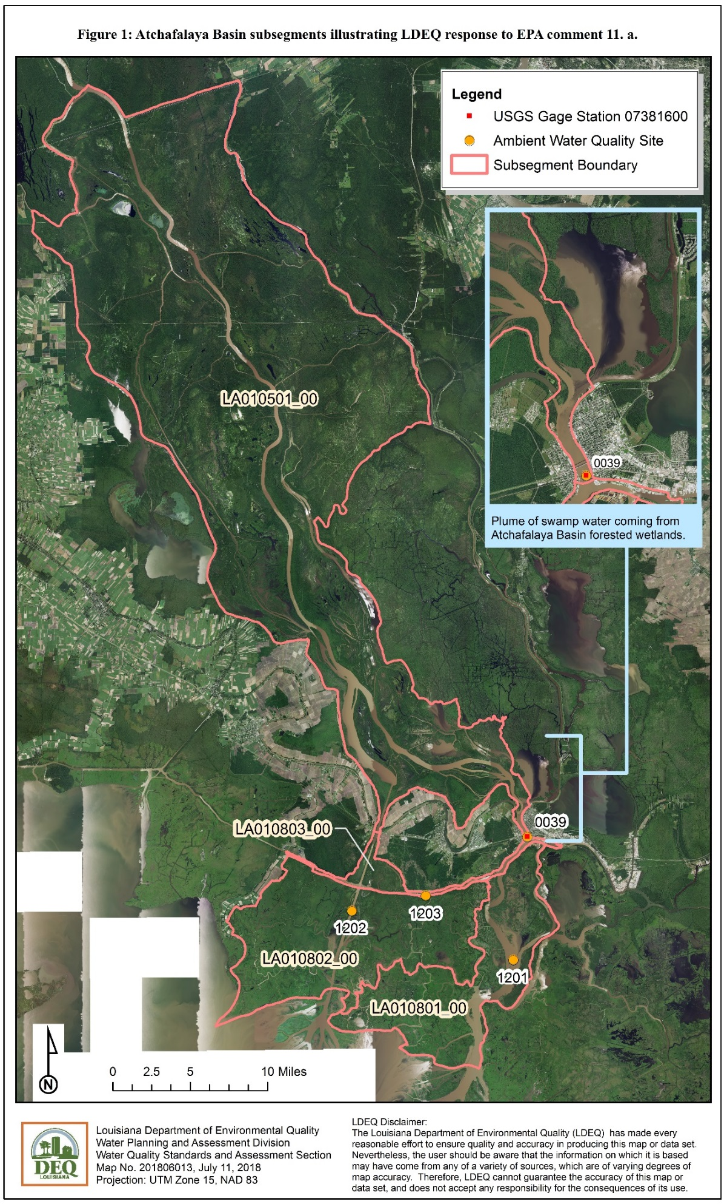
Figure 2: Dissolved oxygen concentrations at USGS site 0738160, Lower Atchafalaya River at Morgan City.
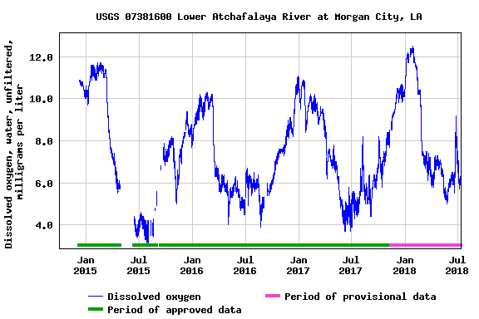

Figure 3: Discharge at USGS site 0738160, Lower Atchafalaya River at Morgan City
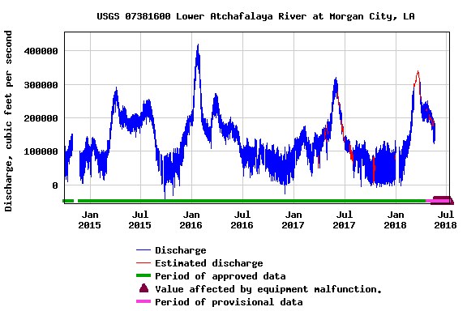
Table 1. Permitted dischargers upstream of LDEQ ambient monitoring site 0039 and USGS site 0738160.
Louisiana Permit Number | Facility Name | Distance Upstream from LDEQ Site (Miles)
LAG490007 | Solar Marine Salvage and River Sand | 1.8
LAG490004 | Sand Inc. – River Sand Pit | 1.4
LAG380056 | City of Morgan City Water System (Drinking water supply) | 1.2
LA0106712 | Conrad Shipyard LLC | 0.9
LAG532523 | U.S. Postal Service – Berwick Post Office | 0.9
LA0126884 | Coastal Tank Cleaning LLC | 0.7

Based on the previous discussion and as permitted by the Clean Water Act, LDEQ choose not to use the USGS data in question for IR purposes. Federal regulation 40 CFR.130.7(b)(6)(iii) allows states to provide “A rationale for any decision to not use any existing and readily available data and information for any one of the categories of waters as described in § 130.7(b)(5).” In this instance LDEQ chose not to use the existing data from USGS because the data is not representative of the overall extent of subsegment 010501. With regard to DO in particular the USGS data is only representative of the small reach of the Atchafalaya River in Morgan City; a reach that is impacted by the forested wetland swamp water plume illustrated in Figure 1.
Therefore, LDEQ respectfully requests that the DO assessment for subsegment LA010501_00 – Lower Atchafalaya Basin Floodway remain fully supported for DO despite the apparent input of naturally low DO forested wetland swamp water in an otherwise high DO river.

USEPA Follow-up to USEPA Comment #13 and LDEQ’s Initial Response:
Following LDEQ’s preceding response to USEPA, and prior to finalization of the 2018 IR, USEPA requested additional documentation to demonstrate that DO is not impaired for the Atchafalaya River at Morgan City.

LDEQ Response to USEPA’s Follow-up to Comment #13:
Based on USEPA’s request for additional information, LDEQ sought out water quality data for Flat Lake and the Atchafalaya Basin swamp immediately upstream of the Atchafalaya River at Morgan City. This effort identified a study conducted by the USGS Louisiana Water Science Center and the Louisiana Department of Natural Resources (LDNR). As part of the study, USGS collected an extensive data set for dissolved oxygen, flow, and a number of other parameters not required for this discussion. All data was collected according to established USGS quality assurance/quality control procedures.
Data for the USGS/LDNR Atchafalaya Basin Program Synoptic Survey was collected between April 2010 and September 2012. While the data was collected outside the period of record for the 2018 IR, it is the most recent and most comprehensive source of data available for the region in question. The data was not used for 2018 IR assessment purposes. Rather, it is being used to support LDEQ’s position that the low DO found in the Atchafalaya River at Morgan City during development of the 2018 IR was from natural sources. Review of the data and other sources of information found that it is representative of conditions in the lower Atchafalaya Basin swamp and Flat Lake over a wide range of flow conditions. As discussed below, the data indicate that flow in the Atchafalaya River and its interconnected swamps are a significant driver of DO concentrations in Flat Lake and subsequently at Morgan City.
Sample sites used in the USGS/LDNR study were located throughout the Atchafalaya Basin, however, this discussion is limited to 11 sites immediately north of Morgan City. This includes nine sites across the northern edge of Flat Lake (Labeled FL-1 through FL-8 in Figure 4), one site at Bear Bayou which drains into Flat Lake from the Atchafalaya Basin, and one site at Drews Pass which drains most of Flat Lake into the Atchafalaya River north of Morgan City. Sites FL-1 and FL-2 appear to be collocated on the map but have distinct DO values in the database, therefore, data for both sites was included in the calculation of means for the FL-1 through FL-8 transect. The distance from Morgan City to Drews Pass is approximately 2.5 miles. From Morgan City to the northern Flat Lake transect sites (FL-1 through FL-8) is approximately 5.0 miles, while the distance to Bear Bayou is approximately 5.8 miles.
Dissolved oxygen data for sites FL-1 through FL-8 was averaged to give an overall value for the northern portion of Flat Lake. The transect is approximately 0.5 – 0.8 miles from the southern edge of the Atchafalaya Basin swamp and the northern shore of Flat Lake. Means for the eight sites are labeled as “Mean DO-Northern Flat Lake” in Figure 5. Dissolved oxygen data for sites FL-5 and FL-6 (“Mean DO-North Central Flat Lake”) was averaged separately to give an indication of the generally lower DO found in the plume coming from the Atchafalaya Basin swamp, primarily through Bear Bayou.
Figure 5 illustrates how periods of relatively low flow through the Atchafalaya Basin swamp, as indicated by flows measured in cubic feet per second (CFS) at Drews Pass and the Atchafalaya River at Morgan City, tend to be related to periods of relatively high DO in the Atchafalaya River, northern Flat Lake and Drews Pass. This finding is in contrast to what was first reported to USEPA in LDEQ’s initial response to USEPA comments (Page F-9). In its initial response LDEQ reported that low flows coincided with low DO readings, on the assumption that low flows indicated drainage of the swamp as flow decreases in the Atchafalaya River. While this may also be a factor, on closer review of the USGS DO and flow data used in LDEQ’s initial response (Figures 2 and 3), and in consideration of the more one-to-one readings of DO and flow provided by the
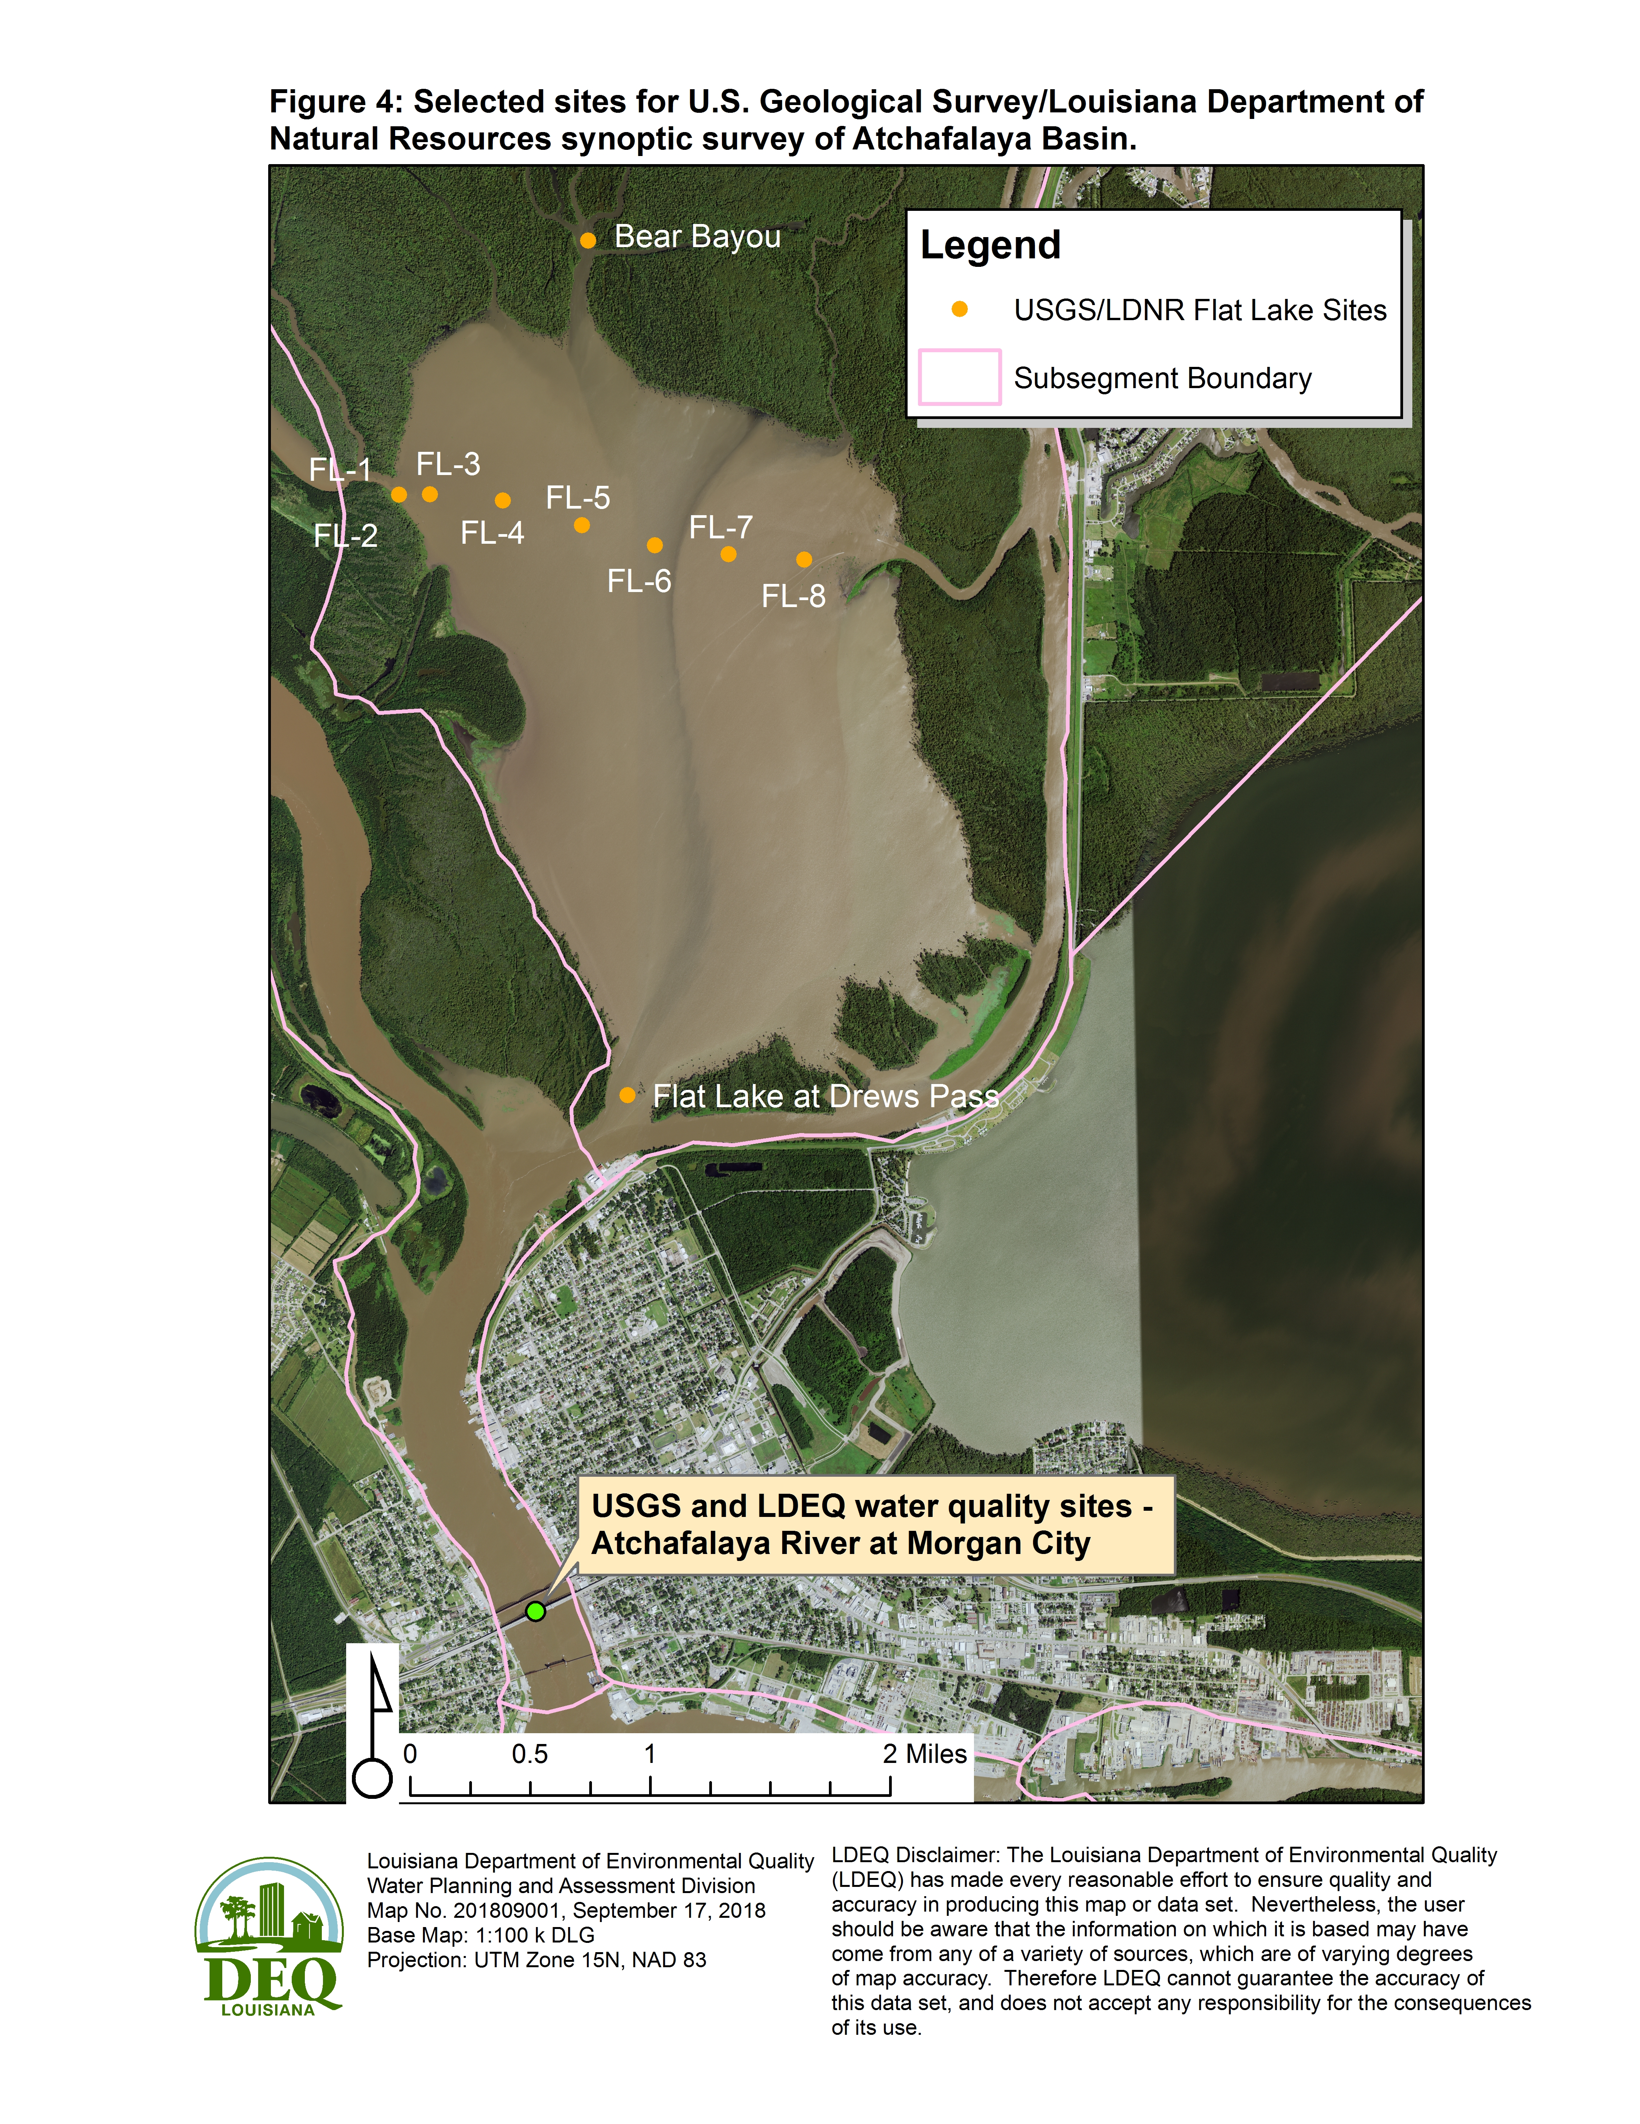

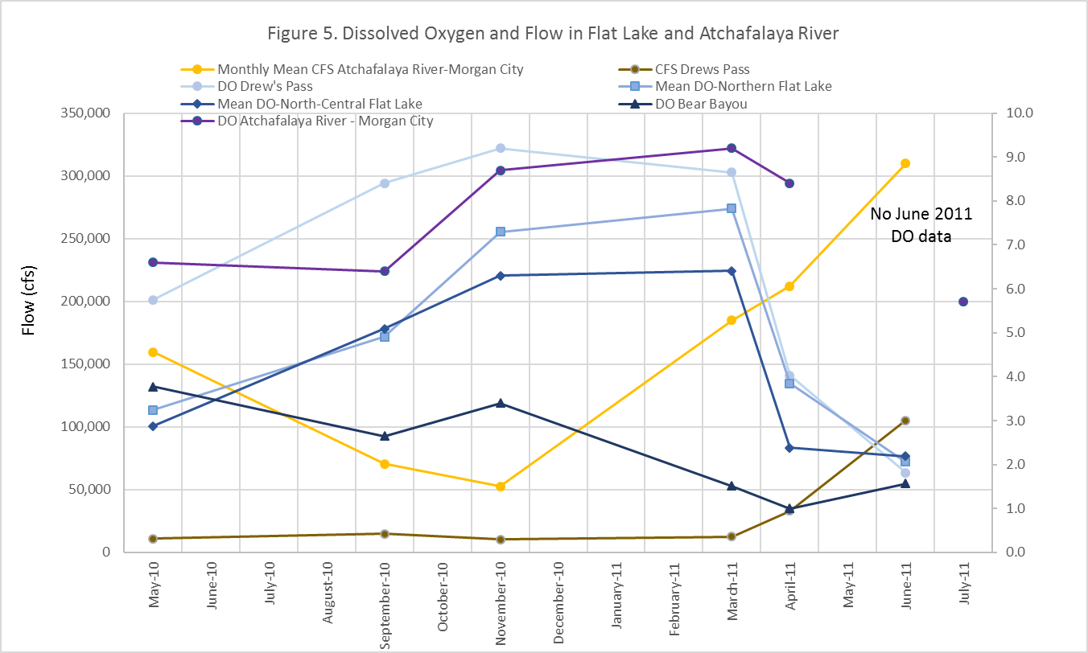
USGS/LDNR data (Figure 5), it is apparent that high flows are more responsible for moving low DO water out of the Atchafalaya Basin swamp, through Bear Bayou, Flat Lake, and Drews Pass. As expected from LDEQ’s initial observations, there is a general DO gradient from low to high running from Bear Bayou, through Flat Lake (In particular at the central Flat Lake sites, FL-5 and FL-6.), out Drews Pass, then on to the Atchafalaya River at Morgan City (Figure 5).
In its follow-up comments USEPA requested LDEQ, “demonstrate that DO conditions just above Morgan City (and just below Drews Pass) are similar to DO conditions at USGS site 07381600.” The USGS/LDNR dataset did not include sites in the Atchafalaya immediately upstream from Morgan City but below Drews Pass. No such data has been located, probably due to the large nature of the river at this point and the proximity of the LDEQ and USGS sites at a bridge in Morgan City. Figure 5 demonstrates that conditions at Drews Pass are similar to conditions at USGS site 07381600 in Morgan City. However, when flows were highest at Drews Pass and the Atchafalaya River at Morgan City DO concentrations at Drews Pass showed a much greater drop from those at Morgan City. This is to be expected due to mixing of low DO water from Drews Pass with higher DO water in the Atchafalaya River. Two sites, American Pass and Dog Island Pass at the Atchafalaya River were sampled in May 2010, September 2010, April 2011, and June 2011. These two sites are 5.6 and 5.1 miles upstream from the LDEQ/USGS sample sites at Morgan City. Dissolved oxygen concentrations at the sites ranged from 4.27 to 8.3 and depended largely on the direction of flow, either out of the pass and into the Atchafalaya River or into the pass from the river. In most cases, if water was flowing out of the pass, i.e. from the swamps, DO was lower in the passes. If water was flowing into the pass, i.e. from the river, DO tended to be much higher in the passes. So while DO data is not available for the precise area requested by USEPA, it is evident that DO in the Atchafalaya River above Morgan City and Drews Pass is well above the criterion of 5.0 mg/L. The three DO values below the criterion (4.27, 4.56, 4.9) occurred during periods when water was flowing out of American Pass and Dog Island Pass, thus representing swamp water and not Atchafalaya River water.
The plume visible in Figure 1 is from a 2015 National Agriculture Imagery Program (NAIP) image, while the plume in Figure 4 is from a 2017 NAIP image. Figure 6 shows NAIP images for 2010, 2013, 2015, and 2017. All four images show varying degrees of a plume coming from the Atchafalaya Basin, flowing through Flat Lake and Drews Pass, then into the Atchafalaya River. The edge of the swamp at Bear Bayou is approximately 5.8 miles upstream of the Morgan City LDEQ/USGS water quality sample site, while Drews Pass is approximately 2.5 miles upstream. (Refer to Figure 4 for locations.)
Based on findings of the USGS/LDNR study, Daniel Kroes with the USGS noted a typical low DO plume of water coming from the northern margin of Flat Lake. Kroes referred to it as “plume of black-water coming out of Bear Bayou and the swamp in general on the north end of Flat Lake.” (Kroes, personnel communication). This is essentially the same plume that can be observed in Figures 1, 4, and 6.
Kroes added that the low DO plume was typically < 2 mg/L and commonly < 1 mg/L, as would be expected of water draining from an extensive swamp. This plume is mixed with higher DO waters in Flat Lake before moving out of the lake through Drews Pass and into the Atchafalaya River north of Morgan City (Kroes, personnel communication). Flushing of the swamp during high water in the Atchafalaya Basin exacerbates the extent of low DO water in Flat Lake and subsequently in the Atchafalaya River. Kroes stated, “It would be reasonable to conclude that water leaving the swamps and Gulf Intracoastal Waterway would stay towards the left bank of the Atchafalaya River and should be high in the water column as water in the swamp is at a higher temperature than in the river.” (Kroes, personnel communication).
Additional information regarding DO conditions in the region came from Bonvillain et al. (2015). During a study of crayfish growth in the Atchafalaya Basin north of Morgan City Bonvillain et al. (2015) found that protracted floodplain flooding from early spring to late summer produced hypoxic conditions in the floodplain as temperatures rose. Hypoxic conditions then spread to other parts of the Atchafalaya Basin as floodplain inundation subsided. Citing Meyer (1992) and Sabo et al, (1996) Bonvillain et al. (2015) noted that well oxygenated water bodies can experience low DO conditions after receiving hypoxic water from floodplains during periods of dewatering.

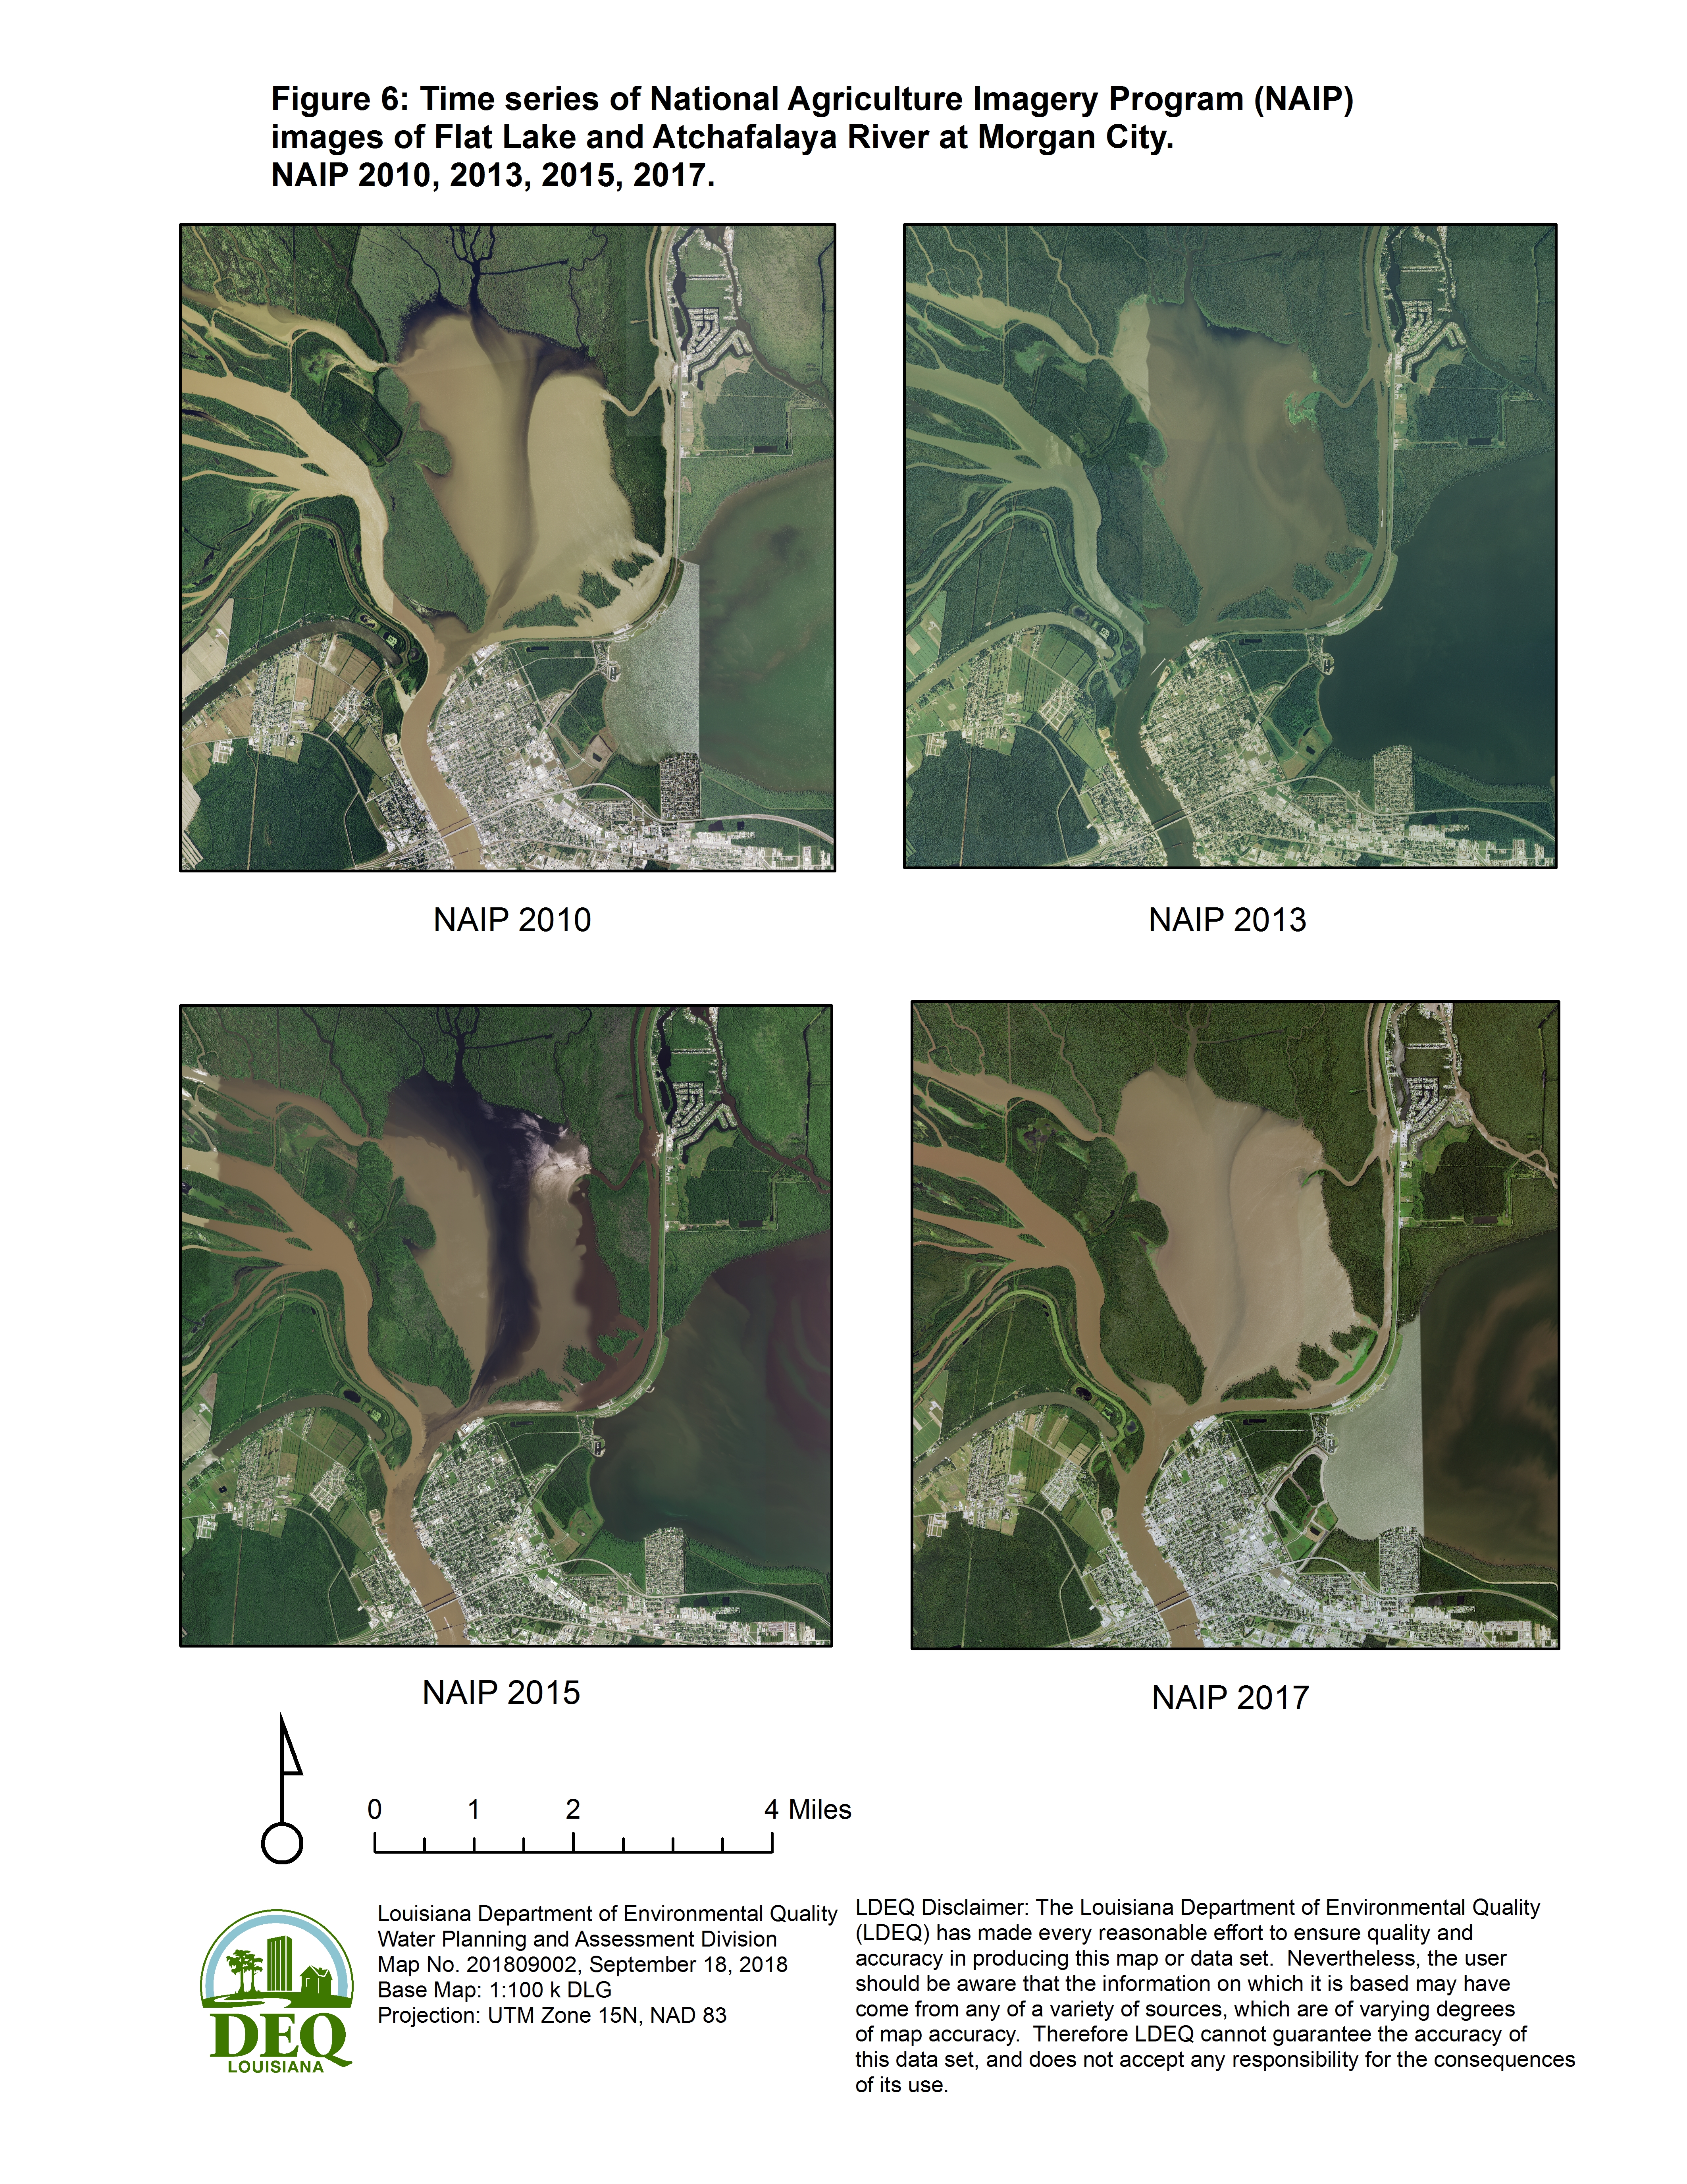
As requested by USEPA, LDEQ also undertook a thorough review of permitted facilities in or near Morgan City and upstream of the LDEQ/USGS water quality monitoring sites. This review located seven additional facilities not previously identified in Table 1. Ten of the facilities are either general or multisector permitted facilities (Table 2, Figure 7). Seven of the facilities do not have outfalls reported in GIS, therefore, they only have stormwater runoff. The largest single permitted discharge is a maximum of 23,000 gallons per day (gps) at Morgan City Tank Cleaners. This amounts to less than 6% of the minimum reported flow of 52,550 CFS in the Atchafalaya River at Morgan City as reported in Figure 5. This low CFS in the river occurred when DO concentrations were the highest (Figure 5). By contrast, at the highest reported Atchafalaya River flow of 309,800 CFS the maximum permitted discharge at the facility would be less than 1% of the Atchafalaya River flow. The highest flow values in the Atchafalaya River and Drews Pass also corresponded with the lowest DO values (Figure 5). All other permitted facilities in the area have maximum discharges of 5,000 gps or are only required to report their monthly average and daily maximum discharges; having no permitted discharge flow limit. Eight of the thirteen facilities identified do not have oxygen demanding parameters as part of their permits. For those facilities with chemical oxygen demand (COD), biochemical oxygen demand (BOD), or total organic carbon (TOC) limits, the permitted limits coupled with the very low daily discharge limits precludes any significant impact on DO concentrations in a river the size of the Atchafalaya at Morgan City. This review of permitted facilities in the area upstream from Morgan City demonstrates that the facilities have a minimal, if any, impact on DO concentrations at the LDEQ and USGS monitoring sites on the Atchafalaya River.
USEPA also expressed concern over stormwater runoff from Morgan City. Therefore, an additional review of the city’s permitted stormwater runoff was conducted. Morgan City operates under LAR041028, a stormwater general permit. Due to the levees separating Morgan City from the Atchafalaya River, and based on the general permit, most of the stormwater from the city goes into Lake Palourde to the east and Bayou Boeuf to the south of the city. This, coupled with the small size of the river makes it unlikely that stormwater runoff from the city would impact DO in the Atchafalaya River.

Table 2:
Permitted facilities along the Atchafalaya River at or near Morgan City and upstream from
LDEQ/USGS water quality monitoring site.
Permit Number | Facility | EDMS Documentation | Flow Rate | COD-Avg. | COD-Max | BOD-Max | TOC-Avg. | TOC-Max
LA0101567 | Morgan City Tank Cleaners | Last document in EDMS is from 2011. Facility was abandoned and no longer operating. LPDES permit was terminated on June 30, 2009. | 23,000 gallons per day (gpd) | 250 mg/L | 400 mg/L | N/A | N/A | 70 mg/L
LA0106712 | Conrad Shipyard | The facility appears to be in good standing. It regularly turns in DMR's and does not have any pending enforcement/compliance actions. Facility is working with Remediation to clean up a former boat slip for heavy metals. | Report monthly average and daily maximum | N/A | 250 mg/L | N/A | N/A | 50 mg/L
LA0126884 | Coastal Tank Cleaning | Facility was inspected in July 2018. No issues were reported. Facility rarely discharges and has no permit exceedance since August 2014. | Report gallons/day | N/A | N/A | N/A | N/A | N/A
LAG380056 | City of Morgan City Water System | Facility is the municipality's potable water treatment plant. It operated under a general permit and does not have oxygen demanding substance reported in DMR's. | LAG380000 limits sanitary discharges to 5,000 gpd; Report monthly average and daily maximum | N/A | N/A | N/A | N/A | N/A
LAG490004 | Sand, Inc. | The facility is a sand & gravel pit that operates under a general permit. Most DMRs report the same average values each month. Facility has no enforcement or compliance issues. Aerial photos show facility is small and not likely a major source of oxygen demanding substances in the subsegment. | LAG490000 limits sanitary discharges to 5,000 gpd; Report monthly average and daily maximum | N/A | N/A | N/A | 8.8 mg/L | 25 mg/L
LAG490007 | Charlies Solar River Sand | The facility is a sand & gravel pit that operates under a general permit. In 2010, facility got warning letters due to sending in DMRs and paying fees. Aerial photos show facility is small and not likely a major source of oxygen demanding substances in the subsegment. | LAG490000 limits sanitary discharges to 5,000 gpd; Report monthly average and daily maximum | N/A | N/A | N/A | N/A | N/A
LAG532523 | Berwick Post Office | Operates under a general permit. Treated sanitary wastewater discharge only. | LAG530000 limits sanitary discharges to 5,000 gpd; Report daily maximum | N/A | N/A | 45 mg/L | N/A | N/A
LAR05M238 | Halliburton Energy Services | Facility operates under a multi-sector general permit. It has no recent enforcement or compliance issues. | N/A | N/A | N/A | N/A | N/A | N/A
LAR05M443 | Stephens Shipyard/ Washburn Marine | LPDES permit terminated in 2008 for Stephens Shipyard. Washburn Marine is now operating in same location without an LPDES permit. Site has numerous complaints concerning sandblasting material blowing off-site. | N/A | N/A | N/A | N/A | N/A | N/A
LAR05M471 | M-I SWACO-Oil and gas field services | Facility operates under a multi-sector general permit. It has no recent enforcement or compliance issues. | N/A | N/A | 100 mg/L | N/A | N/A | 50 mg/L
LAR05M547 | Newpark Drilling Fluids, Inc.-Oil and gas field services | Nothing current in EDMS. Last document from 2007. | N/A | N/A | N/A | N/A | N/A | N/A
LAR05P524 | Intracoastal Liquid Mud-Oil and gas field services | Facility operates under a multi-sector general permit. It has no recent enforcement or compliance issues. | N/A | N/A | N/A | N/A | N/A | N/A
LAR05P952 | Gaubert Oil Company | Facility operates under a multi-sector general permit. It has no recent enforcement or compliance issues. | N/A | N/A | N/A | N/A | N/A | N/A

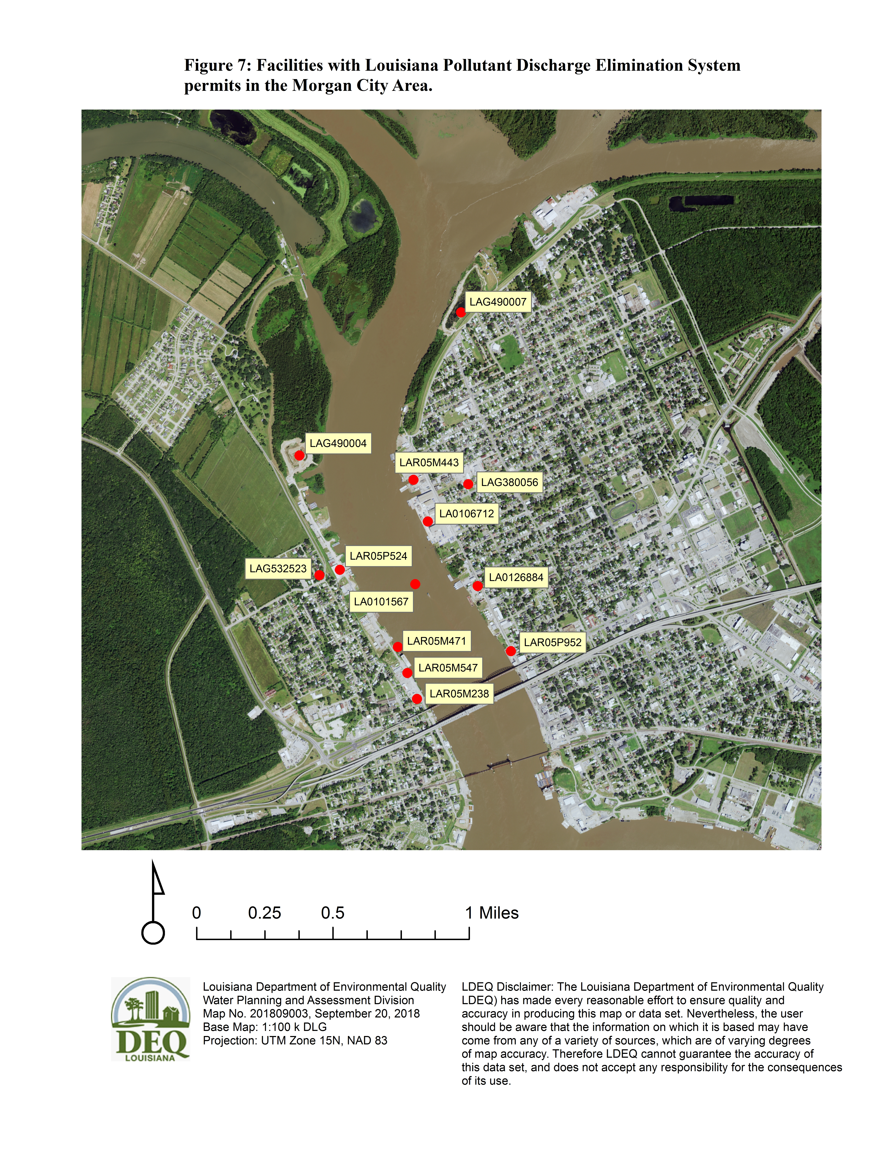

Finally, USEPA expressed concern that bilge water may be impacting DO in the Atchafalaya River. LDEQ does not have any bilge or ballast water permitting requirements for vessels which are underway. Two of the onshore facilities permitted by LDEQ do include discharge of ballast water and/or bilgewater while under repair or construction. Conrad Shipyard (LA0106712) is permitted for the discharge of ballast water. Other discharges from the facility are related to compressor condensate and stormwater runoff with a TOC limit of 50 mg/L to be reported quarterly. Effluent limits for ballast water at Conrad Shipyard are as follows:
Units
(lbs./day, UNLESS STATED) (mg/L, UNLESS STATED)
 | Monthly Average | Daily Maximum | Monthly Average | Daily Maximum | Measurement Frequency | Sample Type
Flow-MGD | Report | Report | -- | -- | 1/event | Estimate
COD | -- | -- | -- | 250 | 1/event | Grab
Oil and Grease | -- | -- | -- | 15 | 1/event | Grab
Visible Sheen | -- | -- | -- | No Presence | 1/day | Observation
pH | -- | -- | 6.0 | 9.0 | 1/month | Grab

Coastal Tank Cleaning (LA0126884) is permitted for the discharge of treated bilgewater, ballast water, and stormwater. Effluent limits for bilge water at the facility are as follows:
Units
(lbs./day, UNLESS STATED) (mg/L, UNLESS STATED)
 | Monthly Average | Daily Maximum | Monthly Average | Daily Maximum | Measurement Frequency | Sample Type
Flow-MGD | Report | Report | -- | -- | 1/month | Estimate
COD | -- | -- | 200 | 300 | 1/month | Grab
TSS | -- | -- | 30.6 | 74.1 | 1/month | Grab
Oil and Grease | -- | -- | -- | 15 | 1/event | Grab
Soaps and Detergents | -- | -- | -- | -- | 1/quarter | Inventory Record
pH | -- | -- | 6.0 | 9.0 | 1/month | Grab

Effluent limits for ballast water at Coastal Tank Cleaning are as follows:
Units
(lbs/day, UNLESS STATED) (mg/L, UNLESS STATED)
 | Monthly Average | Daily Maximum | Monthly Average | Daily Maximum | Measurement Frequency | Sample Type
Flow-MGD | Report | Report | -- | -- | 1/event | Estimate
COD | -- | -- | -- | 250 | 1/week | Grab
TOC | -- | -- | -- | 50 | 1/week | Grab
Oil and Grease | -- | -- | -- | 15 | 1/week | Grab
pH | -- | -- | 6.0 | 9.0 | 1/month | Grab

In addition to the preceding effluent limits at Coastal Tank Cleaning, there are a variety of metals and organic compounds related to the cleaning operations of the facility; however, these are not expected to have a strong oxygen demand. And any oxygen demand would be accounted for by the COD limits.
LDEQ also reviewed requirements for the discharge of bilgewater and graywater as found in USEPA’s Vessel General Permit (VGP) 2013 (https://www.epa.gov/npdes/vessels-vgp). The VGP focuses on the prevention of discharges of oil and grease through best management practices and the use of bilgewater/oily water separators prior to the discharge of bilgewater. All bilgewater discharges are required to be in compliance with 40 CFR Parts 110, 116, and 117; along with requirements of 33 CFR § 151.10. The discharge of graywater under the VGP is based primarily on BMPs to reduce the quantity of graywater and the locations where graywater may be discharged.
Based on both LDEQ’s onshore facility ballast and bilgewater requirements and on USEPA’s VGP requirements, it is not expected that the extremely small discharges of bilgewater, ballast water, or graywater upstream from the LDEQ/USGS water quality sampling point has any effect on DO concentrations in the Atchafalaya River at Morgan City. By way of confirming this expectation, LDEQ offers the following calculation:

According to USGS records, the Atchafalaya River at Morgan City, LA, USGS Station Number 07381600, has the following discharge statistics (15 years of record):

Mean Discharge: 60,000 CFS
Median Discharge: 57,400 CFS
Max Discharge (2008): 117,000 CFS
Min Discharge (2012): 33,700 CFS

Raw, untreated sewage typically has a BOD range of 110 mg/L to 400 mg/L. For the following example, raw sewage with a BOD of 300 mg/L was used. In order to reduce the DO by 1 mg/L in a receiving stream flowing at 60,000 CFS, you would have to discharge more than 34 million gallons per day (MGD) of raw sewage to the river every day. As a comparison, the City of Morgan City Wastewater Treatment Plant, which discharges downstream from the LDEQ/USGS sample point, has a design capacity of 4.5 MGD. Any discharge of bilge or ballast water, even from multiple ships, would be much smaller than this (Dwight Bradshaw (LDEQ), personal communication).
To conclude, based on the preceding follow-up responses to USEPA, LDEQ once again requests that its original DO assessment for the Atchafalaya River at Morgan City, subsegment LA010501_00, remain as fully supporting the DO criterion of 5.0 mg/L. Further, no UAA is required to change the DO criterion, because the appropriate criterion is 5.0 mg/L. This is true despite the occasional occurrence of low DO due to natural swamp drainage from the Atchafalaya Basin swamps through Flat Lake and Drews Pass.

COMMENT #14:
2018 IR Rationale, Table 7: What does “SMB” as listed under Sample Type mean? (USEPA)

LDEQ RESPONSE TO COMMENT #14:
Surface, Middle, Bottom sampling for dissolved oxygen. This will be noted in the final text of the 2018 IR.

COMMENT #15:
Coastal Subsegments Affected by Oil Spill and/or Cleanup Activities, Page 39: How is it known that oil observations at a few of these sites are intermittent? Is it thought that there are no risks to the swimming public during these episodes? (USEPA)

LDEQ RESPONSE TO COMMENT #15:
“Intermittent” refers to the spatial extent of the remaining oil residue as observed during site visits. Based on the intermittent spatial extent and extensive weathering of the remaining oil residue, no risks to the swimming public are expected. Supporting LDEQ’s assessment, a January 2018 fact sheet entitled Is it Safe? Examining Health Risks from the Deepwater Horizon Oil Spill produced by the combined organizations of Gulf SeaGrant, National Oceanic and Atmospheric Administration (NOAA), and the Gulf of Mexico Research Initiative stated, “…studies suggested that exposure to weathered oil, impacted sand, or tar balls after the oil spill would not have a negative effect on humans.” (Report available at: http://education.gulfresearchinitiative.org/safe-examining-health-risks-deepwater-horizon-oil-spill/) The word “spatially” has been added before “intermittent” in the final 2018 IR text to clarify the meaning of the statement.

COMMENT #16:
Rationale for Not Using Readily Available Data and Information, page 54: We GREATLY appreciate the efforts to incorporate outside datasets into the 2018 IR. Can LDEQ identify which data sources, not including those already discussed in the rationale document, were considered but not used in this assessment? Namely, were statewide USGS data found in NWIS examined for use this year? (USEPA)

LDEQ RESPONSE TO COMMENT #16:
A copy of LDEQ’s third-party data summary with reference to the USGS NWIS data and other reviewed datasets was provide to USEPA by email and is available upon request.

COMMENT #17:
2018 IR, Table 11, page 56: We recommend that this table be updated to reflect the present status and plans for ‘Vision’ waters moving forward. (USEPA)

LDEQ RESPONSE TO COMMENT #17:
Table 11 of the 2018 IR Rationale has been updated in the final 2018 Integrated Report text.

COMMENT #18a: Water body specific comments (USEPA):
Please provide data supporting the delisting of Bayou D’Inde (030901) for hexachlorobenzene and hexachlorobutadiene. (USEPA)

LDEQ RESPONSE TO COMMENT #18a:
Based on an agreement between the primary responsible party (PRP), the Louisiana Department of Health (LDH) and LDEQ the PRP discontinued sampling for hexachlorobenzene (HCB) and hexachlorobutadiene (HCBD) following its 2004-2005 sampling effort. At that time concentrations had fallen below risk levels for the two compounds. A PDF copy of the Calcasieu Estuary Biological Monitoring Program: Year 16 Annual Report 2004-2005 has been attached to the response email as Attachment D. HCB and HCBD concentrations can be found in Appendix C of the report. The two compounds were formally removed from the advisory for Bayou D’Inde and portions of the Calcasieu Ship Channel by LDH and LDEQ on November 17, 2016. The reason for the long delay between discontinuing HCB and HCBD sampling and modification of the advisory was due to LDH’s larger concern over PCBs, dioxins, and furans; the presence of which required a continuation of the original advisory. It was sometime prior to the 2016 modification of the advisory that LDH had sufficient data on these three compounds to move forward with the advisory updates. After removal of HCB and HCBD from the advisory the impairment no longer existed and was thus delisted for the 2018 IR. A copy of the revised advisory was provided to USEPA by email and is available upon request.

COMMENT #18b:
Please provide data supporting the delisting of the Amite River (LA040302_00) and Bayou Bonfouca (LA040908_00) for dissolved oxygen. (USEPA)

LDEQ RESPONSE TO COMMENT #18b:
Due to recent changes in subsegment delineations for the eastern Lower Mississippi River Alluvial Plan ecoregion, data from site 0043 – Amite River at Port Vincent was used for both subsegments LA040302_00 and LA040306_00. Site 0043 was within the original subsegment LA040302_00 boundary. After the ecoregion based modifications the site is now located in subsegment LA040306_00. Data for site 0043 is provided in Table 3. LDEQ will investigate the possibility of establishing a new site within the new boundaries for subsegment LA040302_00.

Table 3. Dissolved oxygen data for Amite River (LA040302_00 and LA040306_00) used in 2018 Water Quality Integrated Report.
Site Number | Collection Date | Parameter | Result (mg/L)
0043 | 10/8/2013 | DISS_OXYGEN | 5.73
0043 | 11/12/2013 | DISS_OXYGEN | 7.75
0043 | 12/3/2013 | DISS_OXYGEN | 9.47
0043 | 1/7/2014 | DISS_OXYGEN | 9.95
0043 | 2/13/2014 | DISS_OXYGEN | 11
0043 | 3/11/2014 | DISS_OXYGEN | 7.61
0043 | 4/3/2014 | DISS_OXYGEN | 6.28
0043 | 5/6/2014 | DISS_OXYGEN | 8.14
0043 | 6/3/2014 | DISS_OXYGEN | 5.29
0043 | 7/1/2014 | DISS_OXYGEN | 4.56
0043 | 8/13/2014 | DISS_OXYGEN | 5.16
0043 | 9/9/2014 | DISS_OXYGEN | 4.23

As with the Amite River, due to recent changes in subsegment delineations for the eastern Lower Mississippi River Alluvial Plan ecoregion, data from site 1078 – Bayou Bonfouca, 3.2 miles south of Highway 433, was used for both subsegments LA040908_00 and LA040917_00. Site 1078 was within the original subsegment LA040908_00. After the ecoregion based modifications the site is still located within subsegment LA040908_00. However, the new upstream subsegment LA040917_00 was formerly a part of LA040908_00, making data from site 1078 appropriate for water quality assessment of LA040917_00. Data for site 1078 is provided in Table 4. LDEQ has created a new ambient monitoring site near the boundary between the two subsegments for future monitoring purposes.

Table 4. Dissolved oxygen data for Bayou Bonfouca (LA040908_00 and LA040917_00) used in 2018 Water Quality Integrated Report.
Site Number | Collection Date | Parameter | Result (mg/L)
1078 | 10/9/2014 | DISS_OXYGEN | 7.4
1078 | 11/19/2014 | DISS_OXYGEN | 9.44
1078 | 12/10/2014 | DISS_OXYGEN | 9.15
1078 | 1/13/2015 | DISS_OXYGEN | 8.83
1078 | 2/11/2015 | DISS_OXYGEN | 8.72
1078 | 3/11/2015 | DISS_OXYGEN | 6.95
1078 | 4/15/2015 | DISS_OXYGEN | 4.85
1078 | 5/12/2015 | DISS_OXYGEN | 3.11
1078 | 6/10/2015 | DISS_OXYGEN | 1.7
1078 | 7/15/2015 | DISS_OXYGEN | 4.11
1078 | 8/12/2015 | DISS_OXYGEN | 5.95
1078 | 9/17/2015 | DISS_OXYGEN | 7.11

FOLLOW-UP COMMENT BY USEPA REGARDING COMMENT #18b:
Based on the 2 datasets above, subsegments LA040302_00 and LA040908_00 are impaired (2 exceedances/12 samples).

LDEQ RESPONSE TO FOLLOW-UP COMMENT #18b:
EPA is correct. Dissolved oxygen assessments for subsegments LA040302_00 and LA040908_00 will be changed to impaired. LDEQ inadvertently used the new eLMRAP criteria for the two subsegments instead of the original, and still applicable criteria of 5.0 and 4.0 mg/L, respectively.

COMMENT #18c:
Please provide data supporting the delisting of Thigpen Creek (LA090506_00) for lead. (USEPA)

LDEQ RESPONSE TO COMMENT #18c:
There was no new data collected after 2013, which was the year in which metals data used in the 2016 IR was collected. Therefore, the lead impairment for Thigpen Creek (LA090506_00) should not have been removed from the 2018 IR. It will be added back to the ATTAINS database and other final 2018 IR documentation.

COMMENT 18d;
Grays Creek (LA040304_00) is in IRC 3 in the public notice version of the IR, but is identified in ATTAINs as having been delisted based on a TMDL (IRC 4a). (USEPA)

LDEQ RESPONSE TO COMMENT #18d:
LDEQ is uncertain how the discrepancy came about because the public notice version of the 2018 IR was derived directly from ATTAINS and ATTAINS still indicates IRC 4a for the total phosphorus impairment. Regardless of the cause, LDEQ will ensure the final 2018 IR spreadsheet shows this impairment as IRC 4a.

COMMENT 18e:
Bayous Courtableau (LA060204_00), des Glaises Diversion Channel (LA060207_00), and Boeuf (LA060208_00) were delisted for fecal coliform on the basis that the WQS is no longer applicable. Since the PCR use still applies to these subsegments, please clarify whether the provided delisting reason is accurate. (USEPA)

LDEQ RESPONSE TO COMMENT #18e:
For each of the three subsegments the impairment of fecal coliform was incorrectly removed due to the presence of enterococci data in the IR database. This led to the mistaken interpretation that the fecal coliform criterion no longer applied. However, enterococci data should not have been collected or assessed for the subsegments because the enterococci criterion does not apply. As noted by USEPA the PCR use and fecal coliform criteria do still apply to the subsegments. The impairment of fecal coliform has been restored in ATTAINS and other 2018 IR documentation for each of the three subsegments along with the prior references to TMDLs (IRC 4a) or IRC 5, as needed.
During internal review of the 2018 IR assessments a fourth subsegment, Bayou Carron (LA060210_00), was also identified as having been incorrectly assessed using enterococci data. Therefore, the suspected enterococci impairment originally reported during the public notice period was removed from ATTAINS and the 2018 IR assessments. Fecal coliform remains as a suspected cause of impairment for primary and secondary contact recreation.

COMMENT 18f:
Please provide data supporting the delisting of Grand Isle State Park 2 (LA021102_002) for enterococcus. It was ‘delisted’ in ATTAINS when the cause name was changed to “Enterococcus” from ‘Enterococcus bacteria”, but is not listed as a cause. Is it now meeting criteria? (USEPA)

LDEQ RESPONSE TO COMMENT #18f:
Grand Isle State Park 2 beach (LA021102_002) was originally assessed as unimpaired for enterococcus in the public noticed version of the 2018 IR. However, as noted in LDEQ’s response to USEPA comment 9 the assessments of LDH beach monitoring data was run incorrectly. With the corrected assessments LA021102_002 will be reported as impaired for enterococcus. ATTAINS and other 2018 IR documentation will be updated accordingly.

COMMENT #18g:
Please verify that a TMDL exists for mercury in Calcasieu River-From Marsh Bayou to saltwater barrier (Scenic) (LA030201_00). We have been unable to locate such a TMDL. (USEPA)

LDEQ RESPONSE TO COMMENT #18g:
The mercury TMDL referred to for LA030201_00 is for the Calcasieu River Basin – Coastal Bays and Gulf Waters to state 3-mile limit. Subsegment LA030201_00 and several other inland subsegments that drain to the Gulf of Mexico were first linked to a series of Gulf of Mexico mercury TMDLs due to the area of influence interpretation found in the Calcasieu Basin mercury TMDL and other similar TMDLs. In ATTAINS the Calcasieu River Basin TMDL for mercury is listed as number 2542; however, the PDF document is not available in ATTAINS as it should be. ATTAINS also lists several other mercury TMDLs for Gulf waters, all of which have been associated with inland waters for several IR cycles. Other examples include the following Action ID numbers in ATTAINS: 11642, 11645, 11646, 11662, 11663, 11664, and 2475.

COMMENT #18h:
The new listings for dioxin and furans in the Calcasieu Estuary system are not accounted for in the Calcasieu Toxics TMDL that was revised in 2013. Please place these pollutants in IRC 5 until the TMDL can be updated. (USEPA)

LDEQ RESPONSE TO COMMENT #18h:
Dioxin and furans for the required Calcasieu Estuary subsegments have been placed in IRC 5 in ATTAINS. IRC 4a was initially used based on the Calcasieu Toxics TMDL in the belief that dioxins and furans are “toxins” and, therefore, included in the TMDL.

COMMENT #18i:
We located a fecal coliform TMDL from 2012 for the Natalbany River (LA040503_00). Perhaps this subsegment should be in IRC 4a? (USEPA)

LDEQ RESPONSE TO COMMENT #18i:
LA040503_00 is not impaired for fecal coliform in the 2018 IR. While a fecal coliform TMDL is available in ATTAINS and will be accounted for in permitting and other LDEQ actions, the subsegment should not be reported as impaired, IRC 4a in the 2018 IR.

COMMENT #19:
Atchafalaya Basin Keepers acknowledged the presence of fish consumption advisories due to mercury in selected subsegments of the Atchafalaya Basin and supports renewed testing of fish for mercury. (Atchafalaya Basin Keepers (ABK) and Gulf Restoration Network (GRN) commenting on behalf of ABK, Sierra Club Delta Chapter and Louisiana Environmental Action Network collectively referred to as GRN et al. in this document.)

LDEQ RESPONSE TO COMMENT #19:
Thank you for your comment.

COMMENT #20:
Low oxygen levels are a common problem in many of the small bayous and channels of the Atchafalaya Basin. (ABK)

LDEQ RESPONSE TO COMMENT #20:
LDEQ acknowledges this problem. Thank you for your comment.

COMMENT #21:
Third-party data (USGS) indicates the lower Atchafalaya Basin Floodway (LA010501_00) is impaired by low DO while LDEQ’s assessment reports full support. Comment goes on to state that nutrients in the Atchafalaya River and Mississippi River contribute to the Gulf of Mexico hypoxic zone. Comment also states that source waters for the Atchafalaya Basin contain numerous subsegments impaired due to low DO. (ABK)

LDEQ RESPONSE TO COMMENT #21:
LDEQ data collected at the same location as the USGS continuous monitoring data did indicate possible impairment of DO. However, as noted in the 2018 IR Rationale, evidence indicates that the USGS data and the LDEQ data are likely to have been impacted by natural drainage from the forested wetlands north of Flat Lake. For this reason, the decision was made to not use the USGS data because it was not representative of the entire subsegment. Clean Water Act regulations give states the option to not use data and information, provide a rationale for not using the data is given (40 CFR § 130.7(b)(6)(iii). See also LDEQ’s response to comment 13 submitted by USEPA for additional details.
LDEQ acknowledges that nutrient loading from the Atchafalaya River and Mississippi River contribute to the Gulf of Mexico hypoxic zone. LDEQ also acknowledges that some source water subsegments for the Atchafalaya Basin are impaired for low DO; however, due to the nature of river flow from upstream and flow within the basin, these distant upstream impairments are not related to instances of low DO within the Atchafalaya Basin or the Gulf of Mexico.

COMMENT #22:
The subsegments ICWW from the Bayou Sorrel Lock to Morgan City (LA010502_00) and East Atchafalaya Basin and Morganza Floodway south to I-10 Canal (LA010401_00) are no longer reported as impaired for low DO. Provide justification for removal of these impairments. (ABK and GRN et al.)

LDEQ RESPONSE TO COMMENT #22:
Based on LDEQ’s ambient monitoring data subsegment LA010502_00 was originally found to be fully supporting the fish and wildlife propagation (FWP) use with 9.1% of samples meeting the DO criterion of 5.0 mg/L. Further review of the data found that the one field data meter reading below the DO criterion was affected by the passing of a barge. Such barge movement is known to stir up low DO water and sediment from shallow channels such as the ICWW. This data point has subsequently been rejected, resulting in no DO criterion failures for the subsegment. Subsegment LA010401_00 was also fully supporting the FWP use with 8.3% of samples meeting the DO criterion of 5.0 mg/L. While LDEQ acknowledges the presence of one DO result below the criterion for subsegment LA010401_00, LDEQ’s long established and USEPA approved assessment process allows for up to 10% of DO samples to fall below the promulgated criterion. This assessment process was fully described in the 2018 IR Rationale.

COMMENT # 23:
Water quality criteria must be based on sound science requirements of CWA 40 CFR §131.11(a). Examples of U.S. Fish and Wildlife Service reports on DO requirements for fish, along with Louisiana Coastal Master Plan reports on DO requirements for crayfish are provided in the comment. We request further assessment and analysis be conducted to determine whether the prior suspected sources of impairment to DO have been addressed and to determine the long-term impacts of prolonged exposure to minimum levels of DO on fish and wildlife populations. (ABK and GRN et al.)

LDEQ RESPONSE TO COMMENT #23:
DO criteria for all subsegments in Louisiana are developed using sound science, followed by approval and promulgation in conjunction with USEPA. For Water Quality IR purposes LDEQ is required to use water quality standards and criteria as they exist at the time of report development. Therefore, comments regarding changes to water quality criteria are not appropriate at this time and must be made during periodic standards revision occasions, for example the Triennial Review period.
With regard to further assessment as to whether or not suspected sources still exist, LDEQ does not typically evaluate suspected sources of impairment after the suspected cause of impairment has been removed from the Integrated Report.

COMMENT #24(a) and (b):
- Request that LDEQ provide additional responses to 2016 IR comments from Gulf Restoration Network with regard to nutrient and algal criteria and assessments. (GRN et al.)
- Request response to 2016 affidavit by Dr. JoAnn Burkholder. (GRN et al.)

LDEQ RESPONSE TO COMMENT #24a:
As stated in the 2016 IR response to comments, LDEQ continues to maintain that in the absence of numeric nutrient or algal criteria it is unable to develop an accurate assessment for these constituents. In addition, any reference to the need for development of numeric nutrient or algal criteria is more appropriate for inclusion in comments regarding the Louisiana triennial review process. As noted in LDEQ’s response to comments 1 and 23, for IR purposes the department is required to assess against water quality criteria as they exist at the time of report development.

LDEQ RESPONSE TO COMMENT #24b:
Dr. Burkholder’s comments and LDEQ responses:
- Burkholder Comment: LDEQ’s sampling design seriously underestimated hypoxic/anoxic conditions in the Terrebonne and the other two coastal subsegments for three reasons:
Burkholder Comment (a): LDEQ sampled on only one date per season.
LDEQ Response: LDEQ acknowledges that its Gulf of Mexico DO Study (hereinafter Gulf Study) only sampled each of the three coastal subsegments on one day per season. However, most hypoxic zone studies only sample in one season, the summer, thereby biasing the study results by not considering overall conditions as is required by LDEQ’s IR assessments. Further, fiscal and staff limitations precluded more frequent sampling during the Gulf Study.
Burkholder Comment (b): Two subsegments were not sampled even once during August when hypoxia/anoxia is usually worst, exacerbated by high temperatures.
LDEQ Response: LDEQ acknowledges that two coastal subsegments, Barataria and Mississippi, were not sampled during August; however, both subsegments were still assessed as impaired due to low DO.
Burkholder Comment (c): LDEQ did not acknowledge the known critical season for fish.
LDEQ Response: LDEQ does acknowledge critical seasons, however, as noted above it must consider year-round conditions, not just critical seasons during its assessments.

- Burkholder Comment: LDEQ sampled from ~9 am until ~1:40 pm, mostly from ~9 am to noon. Yet it is well established in science that photosynthesis proceeding from dawn throughout the morning significantly increases DO concentrations.
LDEQ Response: The timing of sampling during the Gulf Study was similar to the timing of routine inshore ambient water quality sampling by LDEQ. While some sampling by LUMCON and other Gulf of Mexico researchers may be at or near dawn, it is unlikely that the majority of sampling by these groups is conducted at that time. This is due, as with LDEQ staff, to time constraints of the ships and research crews. Typically, algal respiration in the water column of the Gulf of Mexico during early morning hours is not the cause of hypoxia. Rather, microbial respiration of organic matter (nutrient and non-nutrient induced) in stratified bottom waters is more often the cause. (CENR, 2000; Bianchi, 2010; Rabalais, et al. 2007). While the process Dr. Burkholder describes is common in well-lit eastern rivers, streams, and estuaries (especially vegetated), the primary control of re-oxygenation in shelf bottom waters is attributed to physical mixing of the water column—which is unrelated to diel photosynthetic processes (DiMarco, et al., 2010; Yu, et al., 2015).

- Burkholder Comment: LDEQ failed to acknowledge the major, known cause of low-DO waters along the Louisiana coast is nutrient pollution. Also, correlation of low-DO with salinity stratification is not causality.
LDEQ Response: LDEQ acknowledges that nutrients from the Midwest are a major cause of low-DO waters in the Gulf. However, the Gulf Study was designed to assess DO levels, not nutrients, in the Gulf throughout the year and throughout the water column. LDEQ’s statements regarding stratification were reflective of the fact that whenever the water column was not stratified, due to rougher conditions at the surface, DO remained higher throughout the water column. Wiseman (1997), CENR (2000), Bianchi (2010), Rabalais (2007) all discuss the requirement of salinity based stratification for the development of hypoxic conditions. CENR (2000) goes so far as to state, “If Louisiana shelf waters did not stratify, hypoxia would be unlikely.” This does not preclude the importance of nutrient input from the Mississippi River, but it does support LDEQ’s finding that stratification is an important factor. LDEQ’s Gulf Study was inadvertently biased toward periods of time when stratification was present, thus increasing the chances of observing low DO in the water column. This bias was caused by the necessity of limiting the sample runs to periods of calmer seas, which was in turn required due to LDEQ’s use of a relatively small twin-engine boat for the sample runs.
LDEQ’s participation in the Mississippi River Gulf of Mexico Watershed Nutrient Task Force (Hypoxia Task Force), the Gulf of Mexico Alliance, and the Louisiana based Nutrient Management Strategy all speak to the importance LDEQ places on nutrient reduction not just in the Mississippi River but throughout Louisiana.

- Burkholder Comment: LDEQ did not notice the strong evidence of algal blooms as indicated by percent saturation.
LDEQ Response: While LDEQ did not mention the high percent saturation in its Gulf Study report it was noticed during the study. As mentioned above, the Gulf Study was designed to assess DO levels, not determine definitive causes or sources of any identified low-DO conditions.
- Burkholder Comment: LDEQ did not use published scientific information related to nutrient pollution to inform its sampling design or its interpretation. The Gulf Study should include algal chlorophyll, and nutrients in the sampling plan, and sample timing should be altered.
LDEQ Response: As mentioned previously, the Gulf Study was designed to assess DO levels, not nutrients or algal chlorophyll. It was not intended as a definitive study on the relationship between DO and nutrients. There are no immediate plans to repeat the Gulf Study; therefore, calls to include algal chlorophyll and nutrients in the sampling plan are not appropriate at this time. Should that opportunity arise, LDEQ will consider the addition of these parameters, however, the daily timing of sampling events is not likely to change due to considerations of safety and logistical constraints placed upon LDEQ’s field sampling crews.

COMMENT #27:
Subsegment LA120806_00 (Coastal Terrebonne) was inappropriately downgraded from IRC 5 to IRC 1 with regard to DO. LDEQ failed to consider data collected by the Louisiana Department of Wildlife and Fisheries (LDWF). (GRN et al.)

LDEQ RESPONSE TO COMMENT #27:
As noted in the 2016 IR Rationale, LDEQ assessed LA120806_00 for DO using long-standing and USEPA approved assessment protocols to evaluate the DO results obtained from its December 2014 – November 2015 Gulf DO study. This is the same protocol used to assess LA021102_00 and LA070601_00 as suspected of impairment for low DO (See response to comment #28). Since finalization of the 2016 IR, no significant additional data was collected by LDEQ in the three coastal subsegments. However, LDEQ did consider third-party data collected by LUMCON and SEAMAP. Results of this consideration, found in Table 7, page 38 of the 2018 IR Rationale, supported LDEQ’s original 2016 IR assessment of full support for DO in LA120086_00.
It should be noted that the website for NOAA’s Hypoxia Watch Project, which was referenced by GRN et al., directs readers to the SEAMAP data collection process. SEAMAP data was reviewed by LDEQ in the 2018 IR Rationale. Because LDWF collected data for the SEAMAP program, LDEQ did in fact consider the LDWF data as found through the NOAA/SEAMAP website. During development of the 2018 IR it was determined that the available SEAMAP data for LA120806_00 was fully supporting of the DO criterion for all 14 available meter readings.

COMMENT #28:
Designate LA 070601_00 (Coastal Mississippi) and LA 021102_00 (Coastal Barataria) as IRC 5 instead of IRC 5RC. (GRN et al.)
LDEQ RESPONSE TO COMMENT #28:
Suspected impairments placed in IRC 5RC (Revise Criteria) are considered “on the § 303(d) list” and are therefore within the guidance set by USEPA. LDEQ is currently working on dissolved oxygen criteria revisions for coastal waters of Louisiana, making IRC 5RC the most appropriate IR category. LDEQ acknowledges that salinity stratification is only one factor in the establishment of hypoxic conditions under certain situations. As was noted by GRN et al., LDEQ stated in the 2018 IR Rationale that nutrient loading from the Mississippi River is also a factor in creating hypoxic conditions. However, any discussion of stratification and nutrients does not negate the need for revised DO criteria; criteria which take into account naturally occurring low DO conditions throughout the depth profile of coastal Louisiana waters.

COMMENT #29:
IRC 5-Alt is not necessary and could be detrimental to the TMDL program. (GRN et al.)

LDEQ RESPONSE TO COMMENT #29:
As was noted in the 2016 IR response to comments, IRC 5-Alt is included in the current guidance developed by USEPA and States. The guidance is known as the Long-Term Vision for Assessment, Restoration, and Protection under the Clean Water Act Section 303(d) Program (“the Vision”) (https://www.epa.gov/tmdl/new-vision-cwa-303d-program-updated-framework-implementing-cwa-303d-program-responsibilities, and https://www.epa.gov/sites/production/files/2015-07/documents/acwa_qa.pdf). Similar to LDEQ’s response to comment 28 regarding IRC 5RC, suspected causes of impairment assigned to IRC 5-Alt are on the § 303(d) list.

COMMENT #30(a) and (b):
Prioritization schedule is (a) inadequate and (b) inaccurate. (GRN et al.)

LDEQ RESPONSE TO COMMENT #30(a):
The 2018 IR prioritization schedule to which GRN et al. is referring is only for the long-term § 303(d)/Vision process (Table 11 of the 2018 Rationale). This table does not include the overall TMDL prioritization provided in the last column of the 2018 IR assessments spreadsheet made available for public comment. Therefore, GRN et al.’s assertion that only seven water bodies will be addressed in the next six years is incorrect. All water bodies in Louisiana, whether they are on the § 303(d) list or not, are addressed with protective actions by water quality standards, water permitting, and in many cases nonpoint source control measures. Section 303(d)/Vision prioritization, as found in Table 11 of the 2018 Rationale, is simply a subset of the overall 2018 IR prioritization.

LDEQ RESPONSE TO COMMENT #30(b):
Section 303(d)/Vision priorities included in Table 11 of the 2018 IR Rationale include some subsegments/impairments that were previously impaired in the 2016 IR but have now become fully supported. These include LA040401_00 (DO) and LA070501_00 (fecal coliform). They were retained in the 2018 IR § 303(d)/Vision priority table in order to maintain continuity with ongoing efforts to improve and protect the water body. Water body protective actions are permitted by USEPA guidance to be included in the § 303(d)/Vision process.
Subsegment LA040504_00 was included in the § 303(d)/Vision priority table, despite having a fecal coliform TMDL, because it was determined that the focused efforts provided by the Vision process would aid in correcting the ongoing cause of impairment to the primary contact recreation use. All of the remaining subsegments found in Table 11 of the 2018 IR Rationale retained the same priority and IRC rankings as those found in the 2016 IR.
COMMENT # 31:
Water bodies have been removed from the § 305(b)/§ 303(d) report without adequate explanation. (GRN et al.)

LDEQ RESPONSE TO COMMENT #31:
Removal of all suspected impairments previously identified in the 2016 IR but found to be no longer impaired for the 2018 IR was based on data and assessment protocols outlined in the 2018 IR Rationale provided for public notice. LDEQ’s assessment protocols used for the 2018 IR have not been substantially changed for over 25 years and should be well known to the public. As in previous IR cycles, given the number of water bodies to be assessed, along with the quantity of data analyzed for each water body, it is not feasible to provide a detailed summary of each suspected impairment removal. The public had access to both the data used for the 2018 IR and the assessment protocols; therefore, it had the opportunity to analyze the data in exactly the same manner as was used by LDEQ.

COMMENT # 32:
LDEQ inappropriately removed the monitoring of metals without supplying details, rationale, or impacts. (GRN et al.)

LDEQ RESPONSE TO COMMENT #32:
LDEQ did provide an explanation for the discontinuation of metals sampling. It can be found in Table 2 of the 2018 IR Rationale and will also be in the final 2018 IR. By way of further explanation, not including the mercury impairments due to fish consumption advisories, Louisiana currently has ten subsegments suspected of impairment due to metals; eight for lead, two for copper, and one for arsenic. Most of these subsegments are in areas with no obvious anthropogenic sources for the metals, making it unlikely that the elevated metals concentrations can be alleviated by TMDLs or other actions by LDEQ. All of the suspected metals impairments are based on historical sampling from both semi-clean and ultra-clean sampling. During the time period in which LDEQ conducted semi-clean sampling on a quarterly basis on all subsegments, the vast majority of the results were either non-detect or below criteria. If detections were above criteria, then ultra-clean follow-up sampling typically resulted in either no detection or were below criteria. Further, several years ago USEPA Region 6 attempted to develop a list of subsegments that, based on historical metals data, were most likely to have elevated metals and therefore warrant ultra-clean sampling efforts. This effort was discontinued by USEPA when they were unable to discern any patterns in metals contamination across the state. As a result, while LDEQ agrees that metals sampling would be advantageous in the future, the high cost of ultra-clean metals sampling cannot be justified at this time by the low expectation of finding areas of concern with regard to metals.

COMMENT # 33:
Wetlands assimilation subsegment LA120207_00 for Thibodaux is not meeting LDEQ criteria. (GRN et al.)

LDEQ RESPONSE TO COMMENT #33:
Following the public notice period, based on GRN et al’s comment, USEPA’s follow-up comments, and further discussion with USEPA staff, LDEQ revised its wetlands assimilation area assessment process, making this comment moot. The new assessment process can be found in Part III, Chapter 2 of the full text of the 2018 IR. As part of this revision, the wetland assimilation subsegment LA120207_00 is now reported as impaired for the designated use of fish and wildlife propagation.

COMMENT # 34:
Subsegment LA040803_00 should be listed in IRC 3. (GRN et al.)

LDEQ RESPONSE TO COMMENT #34:
The Guste Island wetland assimilation area, which is located within subsegment LA040803_00 (Tchefuncte River-From La. Highway 22 to Lake Pontchartrain), is not a subsegment in Louisiana regulations and there are no plans to create a subsegment for the area (LAC 33:IX.1123.D Table 3). This is why it is not listed in IRC 3. Any future assessment of Guste Island will be done only as an aid to permitting and enforcement for the assimilation area and will not be reflected in subsequent IR spreadsheets or ATTAINS as an assessment for IR purposes.

COMMENT # 35:
All criteria, including general criteria were not assessed. (GRN et al.)

LDEQ RESPONSE TO COMMENT #35:

As has been noted previously, in the absence of numerical criteria LDEQ is unable to conduct IR assessments using available water quality data and information. While not typically used for IR assessments, the general criteria found in LAC 33:IX.1113.B are used by LDEQ surveillance and enforcement staff during their investigations of complaints and incidents.

COMMENT # 36:
Louisiana should assess nutrients using the General Criteria. (GRN et al.)

LDEQ RESPONSE TO COMMENT #36:
As noted by GRN et al., Louisiana has been attempting to develop numeric nutrient criteria since at least 2006. In actuality, the effort has been ongoing since the mid-1980s. The length of time this effort has already taken is indicative of the difficulties involved in setting accurate and defensible nutrient criteria. Louisiana is not alone in finding nutrient criteria development a difficult task. Part of the narrative criteria requires knowing the “naturally occurring range of nitrogen-phosphorus ratio” to be maintained. This requirement is a key part of the difficulty in developing numerical criteria.

COMMENT #37:
In the course of internal review following the public notice comment period it was determined that subsegment LA080201_00 (Ouachita River - From Columbia Lock and Dam to Jonesville) was inadvertently not reported as impaired due to the presence of a mercury fish consumption advisory. When the original Ouachita River advisory was revised in 2003 it included the portion of the river delineated as LA080201_00; previously this portion was not included. Following the 2003 revision LDEQ failed to update the IR assessment for that subsegment to include the mercury advisory impairment. This impairment has been added for the 2018 IR. (LDEQ)

COMMENT #38:
In the course of internal review following the public notice comment period a new fish consumption advisory due to the presence of mercury in fish tissue was issued by LDEQ, LDH, and LDWF. The new advisory is on Two O’Clock Bayou in St. Landry Parish. The new “advisory only” subsegment LA010301_003 was created in ATTAINS to recognize this new advisory water body. (LDEQ)

Literature Cited
Bianchi, T.S. and S.F. DiMarco, J.H. Cowan Jr., R.D. Hetland, P. Chapman, J.W. Day, M.A. Allison. 2010. The science of hypoxia in the Northern Gulf of Mexico: A review. Science of the Total Environment. 408. pp. 1471-1484.
Bonvillain, C.P. and D.A. Rutherford, W.E. Kelso. 2015. Effects of environmental hypoxia on population characteristics of red swamp crayfish Procambarus clarkii in the Atchafalaya River Basin, Louisiana. Hydrobiologia. 743, 1 pp 309-319.
Committee on Environment and Natural Resources (CERN). 2000. Integrated assessment of hypoxia in the northern Gulf of Mexico. National Science and Technology Council. May 2000.
DiMarco, S.F., and P. Chapman, N. Walker, R. Hetland. 2010. Does local topography control hypoxia on the eastern Texas—Louisiana Shelf? Journal of Marine Sciences. 80, 20-35.
Hunter R, and G. Shaffer, R. Lane, J. Day. 2016. Analysis of Long-Term Productivity and Nutrient Removal at Assimilation Wetlands in Coastal Louisiana. Report no. LDEQ OCR No. 855-400144, USEPA Grant #I-00F59701, Final Deliverable. http://edms.deq.louisiana.gov/app/doc/view.aspx?doc=10464993&ob=yes&child=yes.
Meyer, J.L. 1992. Seasonal patterns of water quality in blackwater rivers of the coastal plain, southeastern United States. In Becker, C.D. & D.A. Neitzel (eds), Water Quality in North American River Systems. Battelle Press, Columbus, OH: 249-276.
Rabalais, N.N. and R.E. Turner, B.K. Sen Gupta, D.F. Boesch, P. Chapman, M.C. Murrell. 2007. Hypoxia in the Northern Gulf of Mexico: does the science support the plan to reduce, mitigate, and control hypoxia? Estuaries and Coasts. 30,5. pp. 753-772.
Sabo, M.J., and C.F. Bryan, W.E. Kelso, D.A. Rutherford. 1999. Hydrology and aquatic habitat characteristics of a riverine swamp: II. Hydrology and the occurrence of chronic hypoxia. Regulated Rivers 15: pp. 525-542.
Yu, L., and K. Fennel, A. Laurent. 2015. A modeling study of physical controls on hypoxia generation in the northern Gulf of Mexico. Journal of Geophysical Research: Oceans. 120, 5019–5039, doi:10.1002/2014JC010634.
US Environmental Protection Agency (EPA). 2016. Approval Letter for report Analysis of Long-Term Productivity and Nutrient Removal as Assimilation Wetlands in Coastal Louisiana. USEPA Grant #I-00F59701. Finale Deliverable. http://edms.deq.louisiana.gov/app/doc/view.aspx?doc=10464980&ob=yes&child=yes.
Wiseman, W.J. and N.N. Rabalais, R.E. Turner, S.P. Dinnel, A. MacNaughton. 1997. Seasonal and interannual variability within the Louisiana coastal current; stratification and hypoxia. Journal of Marine Systems. 12. pp. 237-248.

