APPENDIX A: 2018 Integrated Report of Water Quality in Louisiana
Appendix A is taken from Louisiana’s 2018 ATTAINS database, which contains all water quality assessments for the state. All suspected causes of impairment and suspected sources of impairment are linked in a one to one fashion, meaning, a reported suspected cause of impairment is believed to be affected by the suspected source of impairment provided on the same line of the table. However, as a result of this linking, some suspected causes and/or sources may be listed more than once for a given water body subsegment. This results in cases where a suspected cause of impairment has two or more suspected sources of impairment. Likewise, if a suspected source of impairment affects two or more suspected causes of impairment, the suspected source will be listed more than once. This is important to note in order to prevent double counting when attempting to develop subtotals for the size or number of water bodies affected by a given suspected cause or suspected source of impairment.
The full water quality assessment table is contained in Appendix A at: 18_IR1-FINAL-Appendix A-All Assessments.
Descriptions and designated use support maps for each of the 12 basins follow. Numbers on maps (e.g. LA010101_00) correspond to water body subsegments in the Excel spreadsheet assessment table found in Appendix A-All Assessments.

Assessment Table Header Information
Type = water body type
R = river
L = lake
E = estuary
W = wetland
C = coastal waters

Designated Uses and Codes:
PCR = primary contact recreation (swimming)
SCR = secondary contact recreation (boating)
FWP = fish and wildlife propagation
DWS = drinking water supply
ONR = outstanding natural resource waters
AGR = agriculture
OYS = oyster propagation
LAL = FWP subcategory of limited aquatic life and wildlife
IR Category and TMDL Codes:
IR Category for Suspected Causes = Integrated Report Category. See Part III, Chapter 2 in the IR text for details of these categories.
TMDL Priority = priority order in which TMDLs will be developed, based on LDEQ 303(d)/TMDL Vision.

Designated Use Support Statements
Designated uses are assessed as either fully supported or not supported based on water quality assessment procedures described in Part III, Chapter 2 of this report. In some cases insufficient data or no data are available with which to make an assessment. Where a designated use exists for a water body subsegment, letters are used in that column to indicate the 2014 assessment of that use. These letters are defined as follows:
F = Fully supporting the designated use
N = Not supporting the designated use
I = Insufficient data to make an assessment
X = No data with which to make an assessment

Descriptions of Louisiana’s Watershed Basins
For water quality management purposes, Louisiana is divided into 12 large-scale watershed basins. These basins are based on 11 river watersheds plus the Lake Pontchartrain watershed. For management purposes, these basins were assigned numbers for use in watershed segment and subsegment delineation. These subsegments are described in more detail in Part II, Chapter 2 of this report. The 12 basins and their associated numbers are:
Atchafalaya River Basin (01)
Barataria Basin (02)
Calcasieu River Basin (03)
Lake Pontchartrain Basin (04)
Mermentau River Basin (05)
Vermilion-Teche Basin (06)
Mississippi River Basin (07)
Ouachita River Basin (08)
Pearl River Basin (09)
Red River Basin (10)
Sabine River Basin (11)
Terrebonne Basin (12)

ATCHAFALAYA RIVER BASIN (01)
The Atchafalaya River Basin is located in the south central part of Louisiana. The Atchafalaya River is a distributary of the Red, Black, and Mississippi Rivers, presently carrying about 30% of the Mississippi's flow. The basin is well-defined by a system of levees, which surround it on the north, east, and west. The entire basin serves as a major floodway for Mississippi River floodwaters. It encompasses approximately 1,806 square miles and is predominantly wooded lowland and cypress-tupelo swamp with some fresh water marshes in the lower distributary area. It constitutes the largest contiguous fresh water swamp in the United States.
Maps showing use support for the three most significant designated uses of primary contact recreation (swimming), secondary contact recreation (boating), and fish and wildlife propagation (fishing) are on the following three pages.

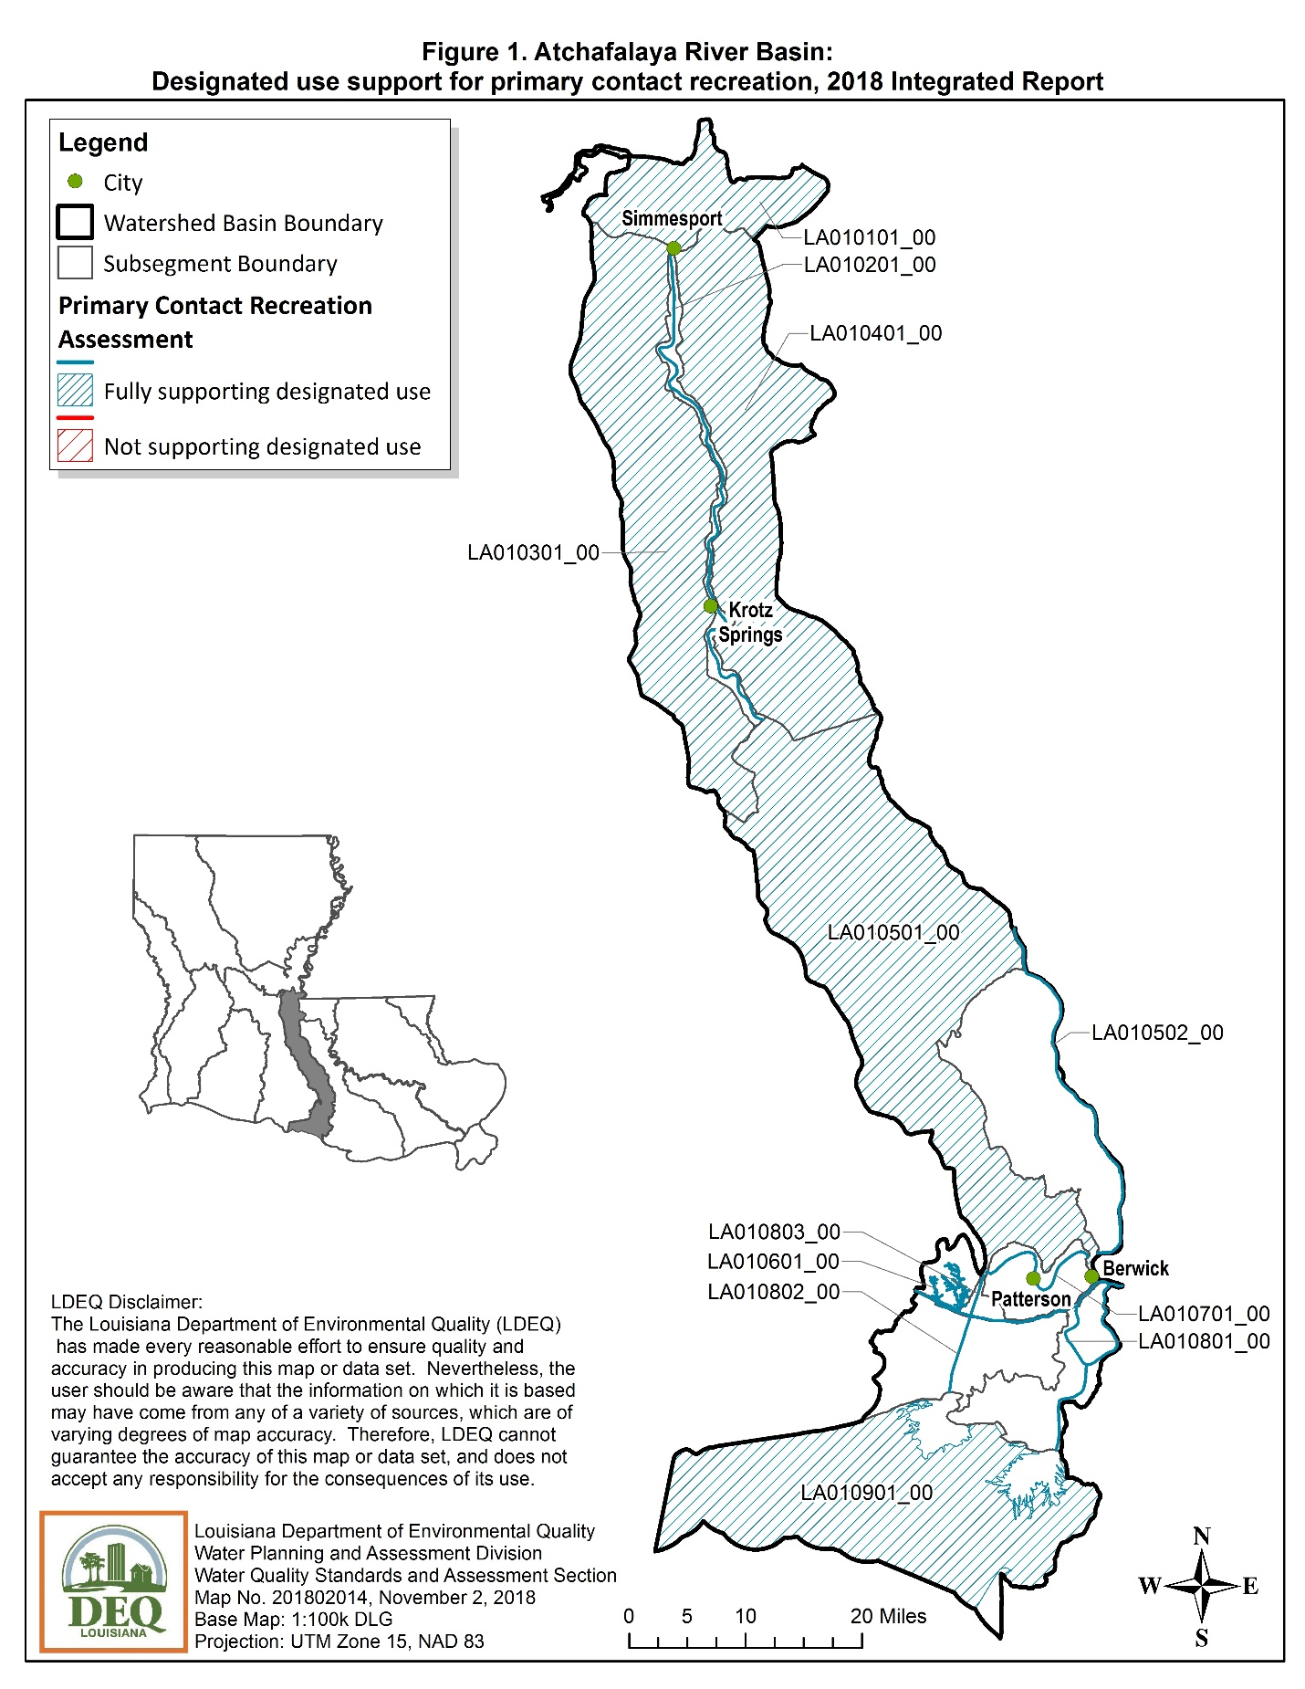
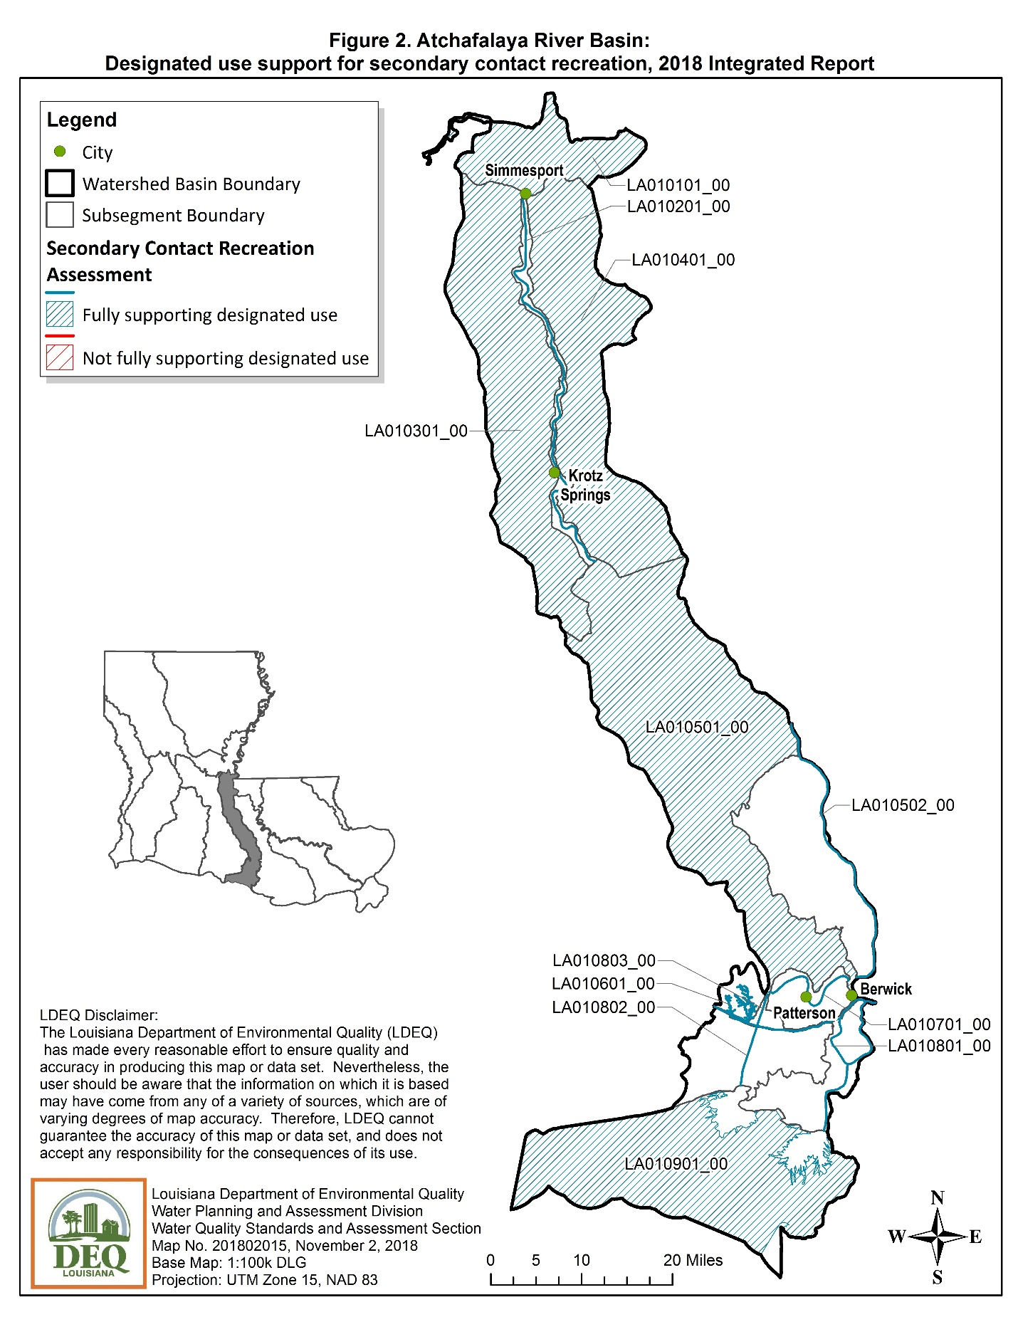
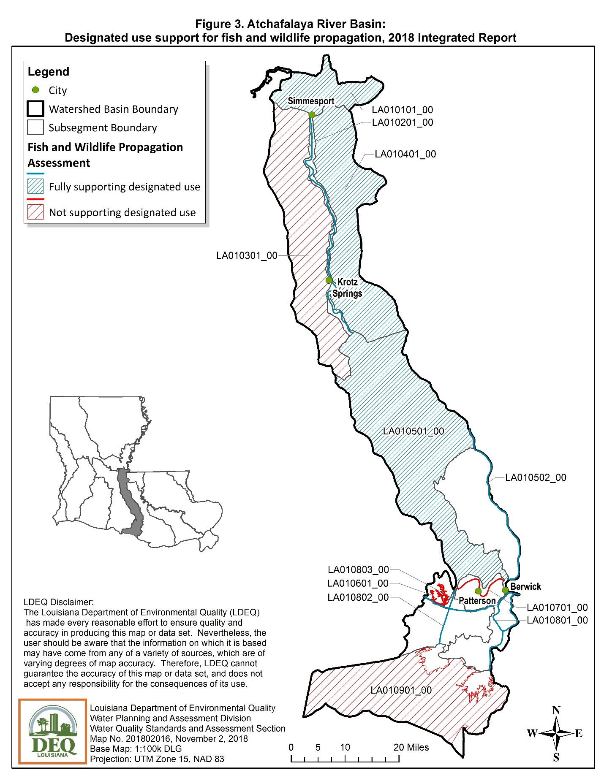
BARATARIA BASIN (02)
The Barataria Basin lies in the eastern coastal region of the state. This basin is bounded on the north and east by the lower Mississippi River, on the west by Bayou Lafourche, and on the south by the Gulf of Mexico. The major receiving water body in this basin is Barataria Bay. The Barataria Basin consists largely of wooded lowlands and fresh to brackish marshes, having some saline marsh on the fringes of Barataria Bay. Elevations in this basin range from minus two feet to four feet above sea level.
Maps showing use support for the three most significant designated uses of primary contact recreation (swimming), secondary contact recreation (boating), and fish and wildlife propagation (fishing) are on the following three pages.

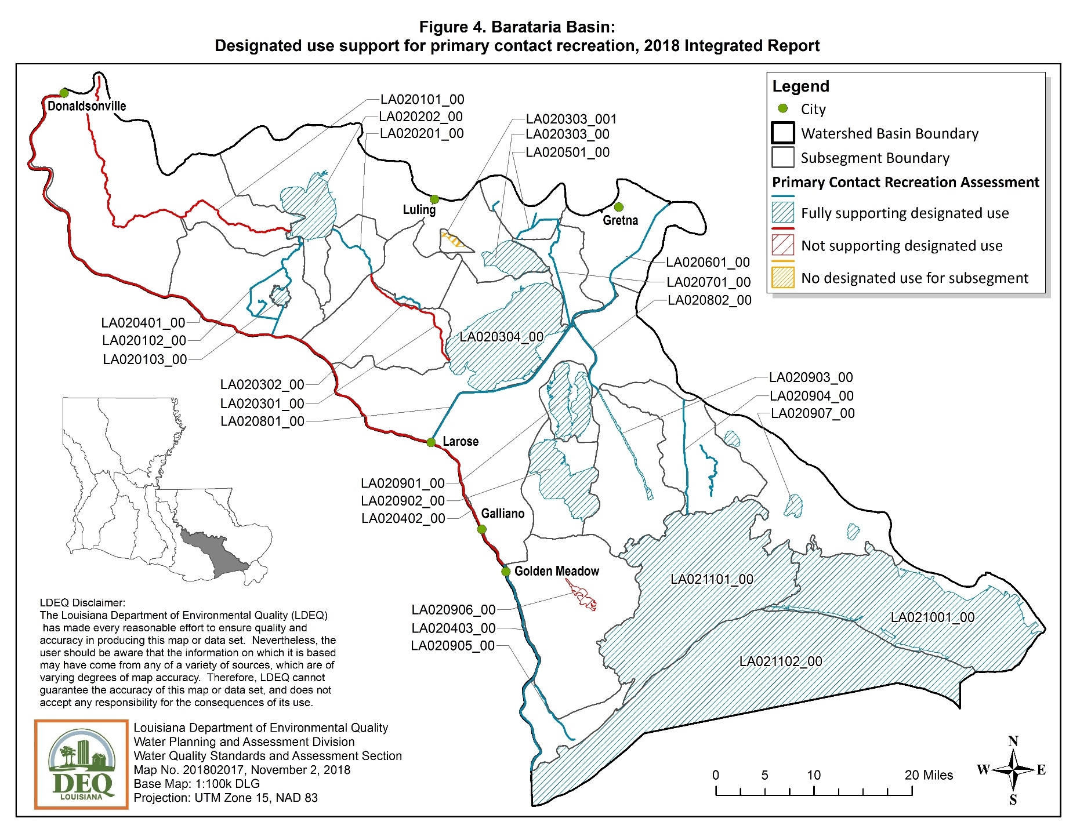
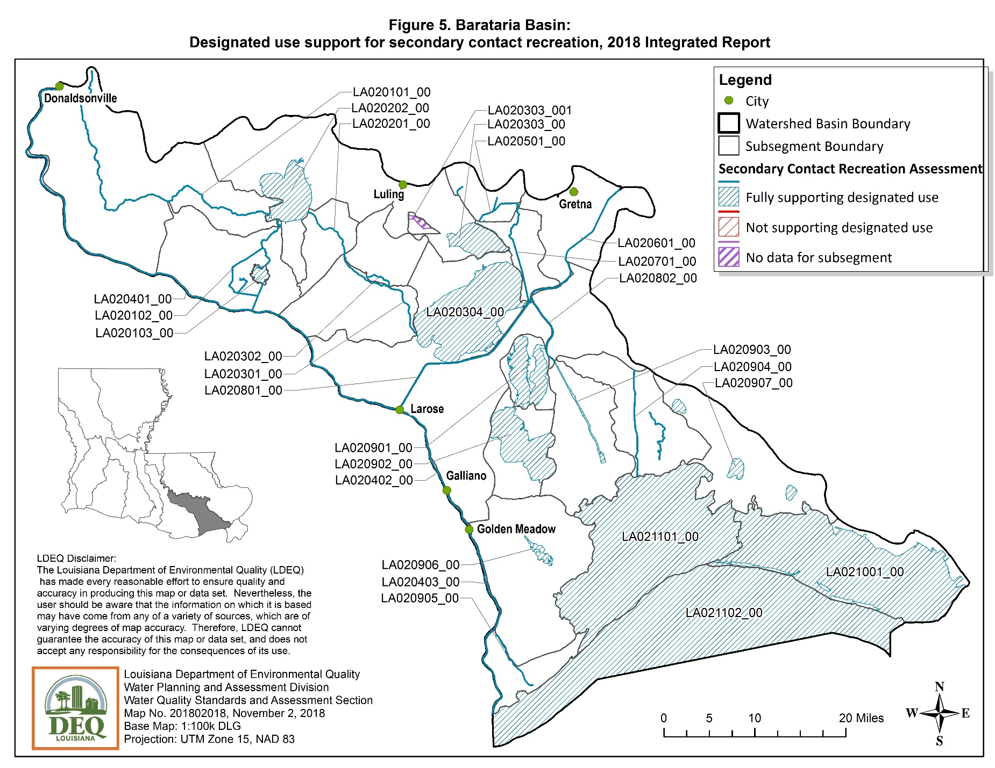
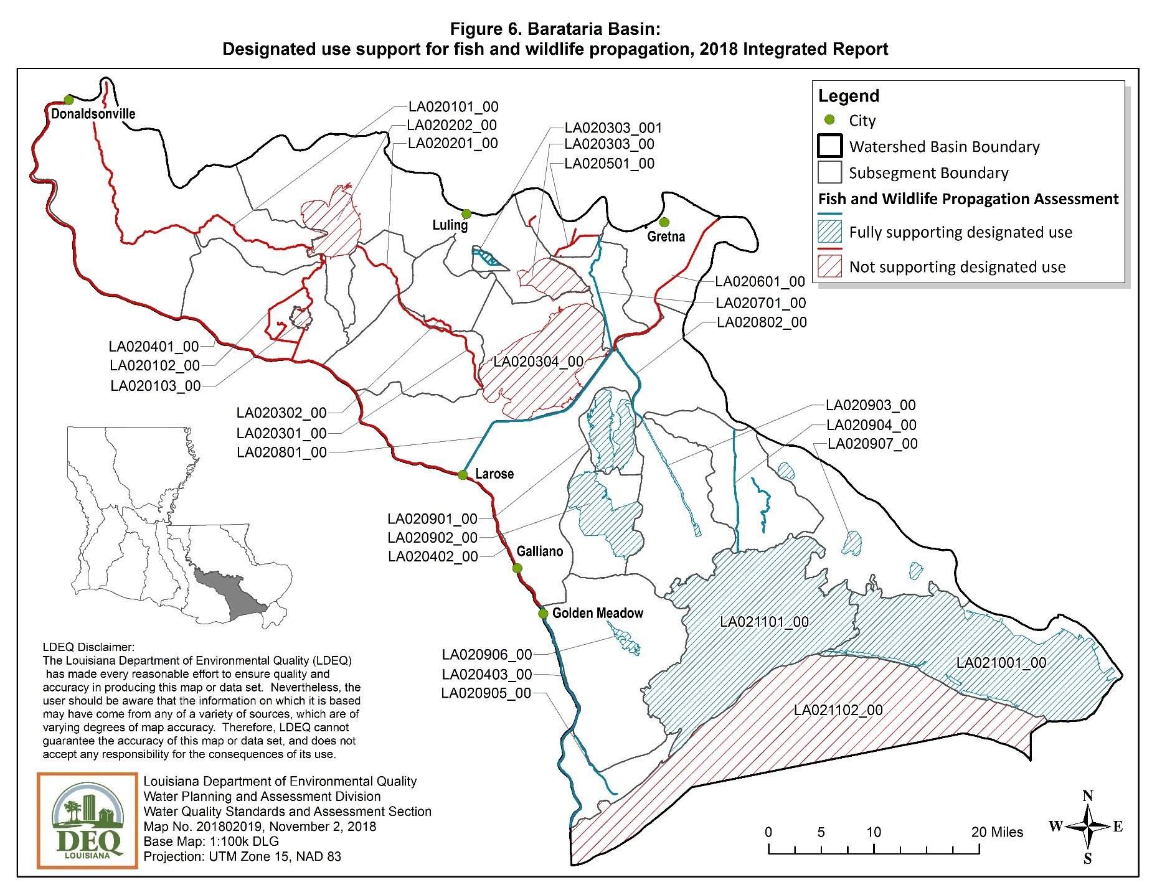

CALCASIEU RIVER BASIN (03)
The Calcasieu River Basin is located in southwestern Louisiana and is positioned in a north-south direction. The drainage area of the Calcasieu Basin comprises approximately 3,910 square miles. The headwaters of the Calcasieu River are located in the hills west of Alexandria and the river flows south for about 160 miles to the Gulf of Mexico. The mouth of the river is about 30 miles east of the Texas-Louisiana state line. The landscape in this basin varies from pine-forested hills in the upper end to brackish and salt marshes in the lower reach around Calcasieu Lake.
Maps showing use support for the three most significant designated uses of primary contact recreation (swimming), secondary contact recreation (boating), and fish and wildlife propagation (fishing) are on the following three pages.

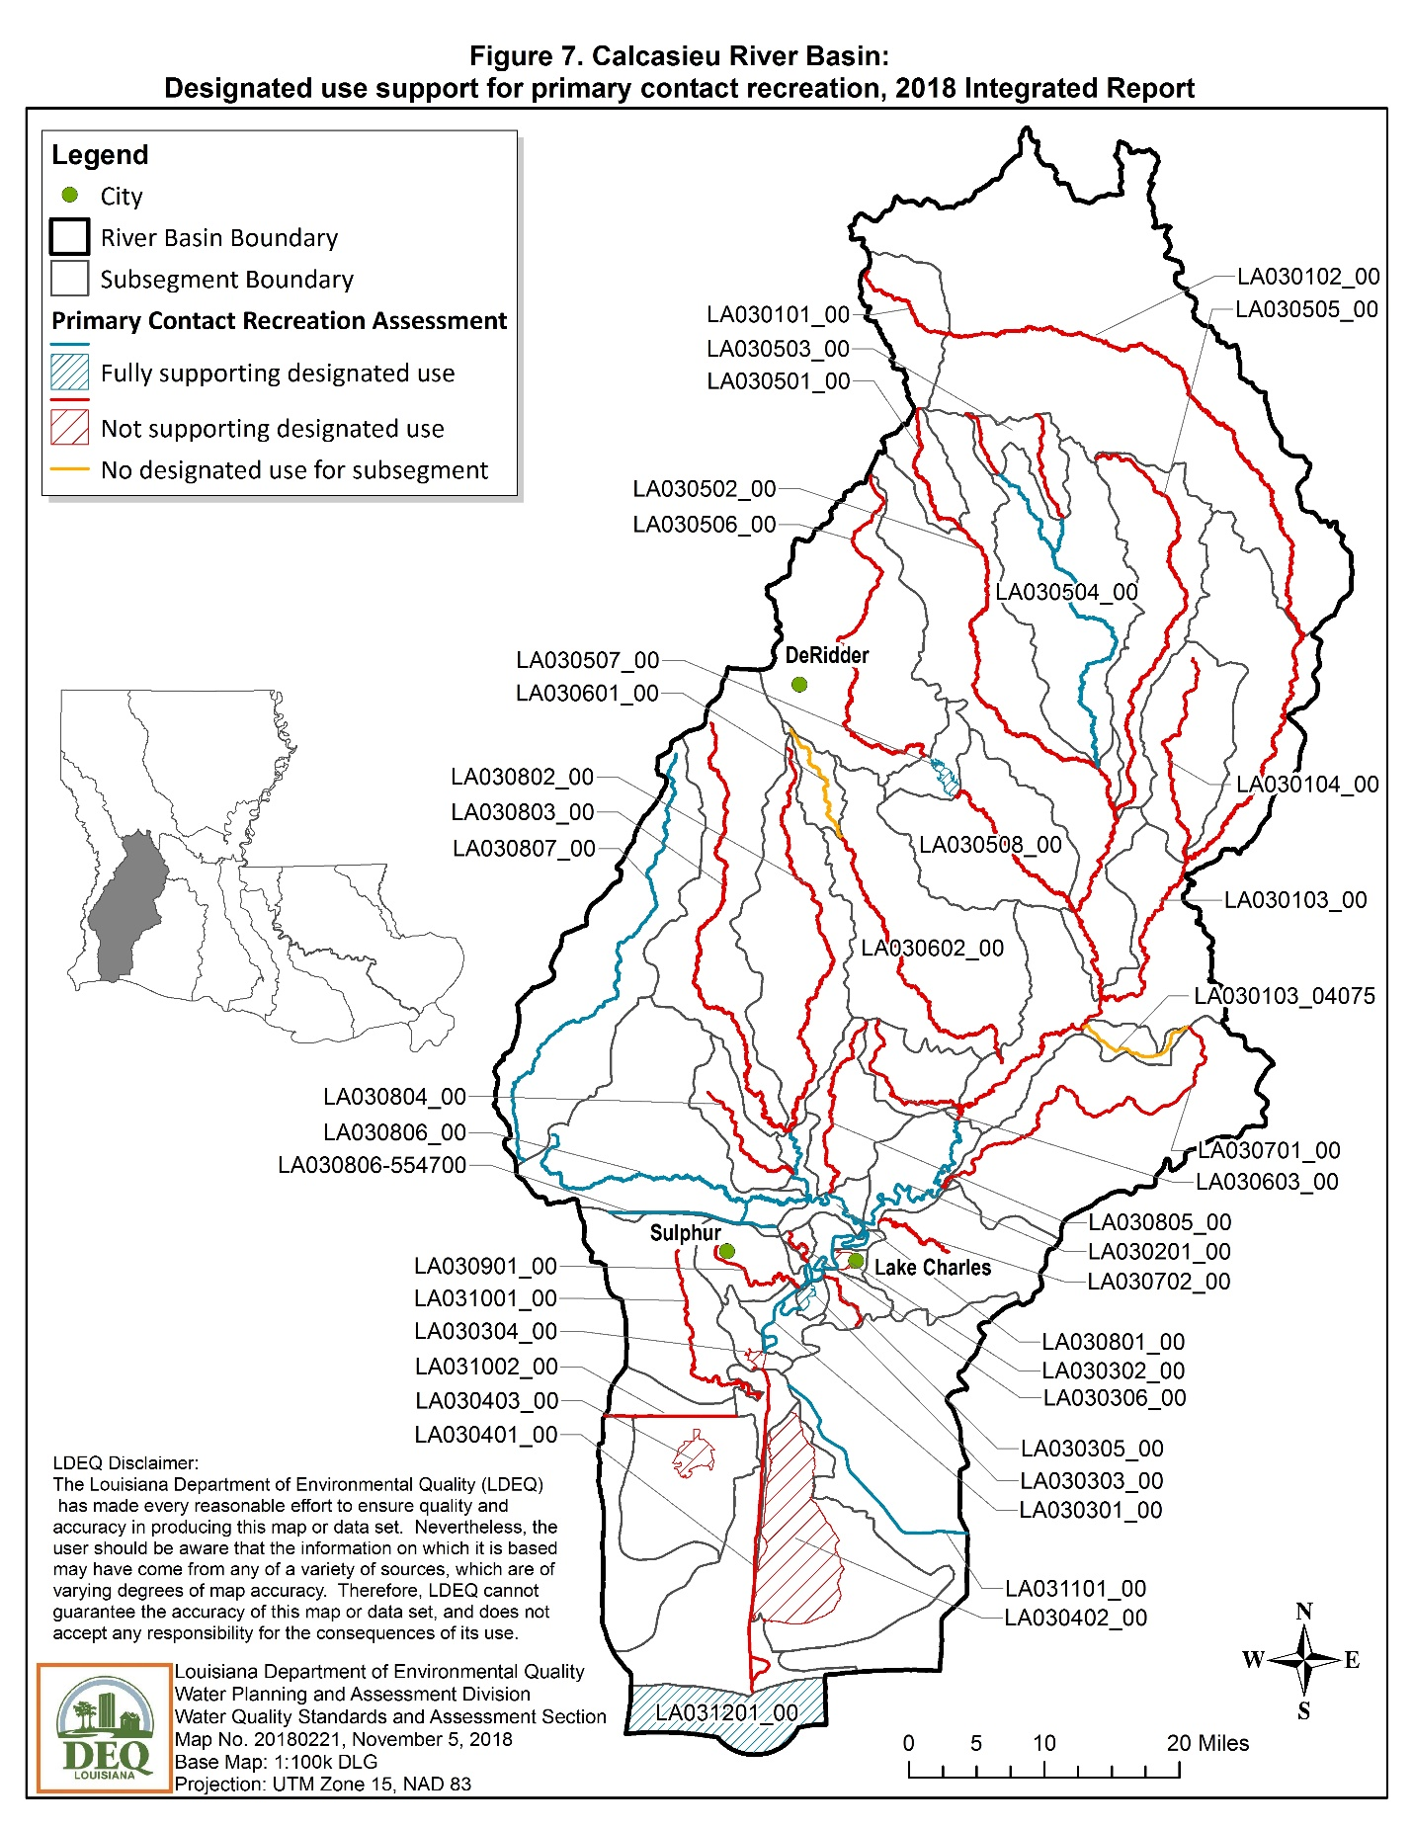

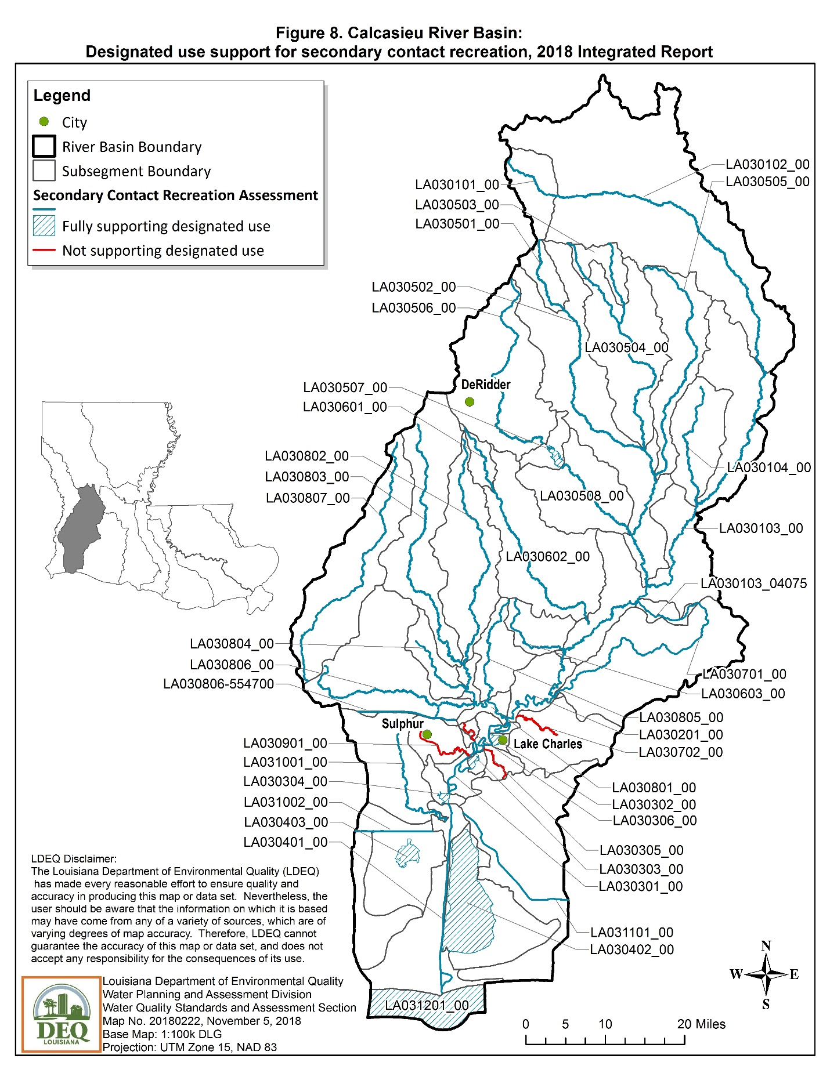

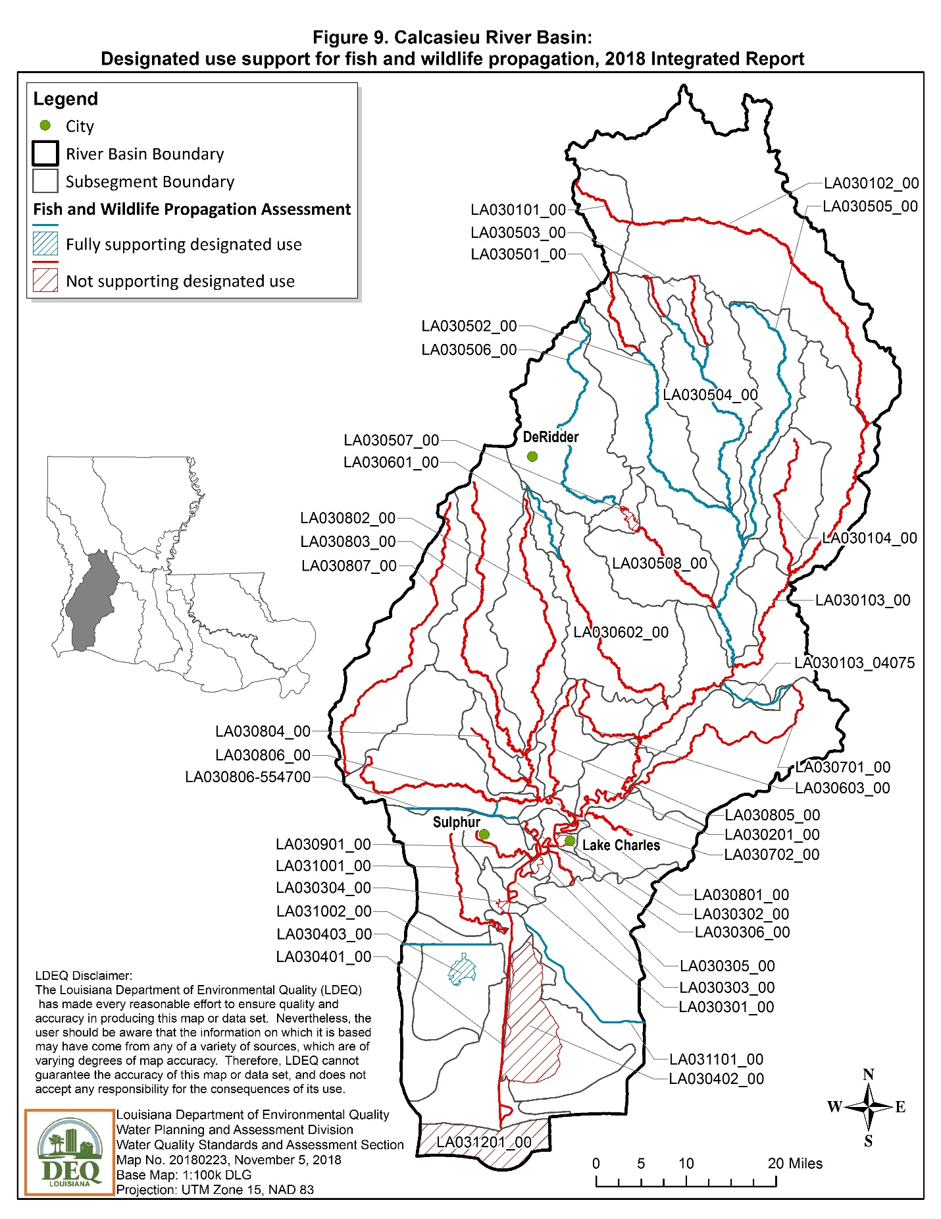
LAKE PONTCHARTRAIN BASIN (04)
The Lake Pontchartrain Basin, located in southeastern Louisiana, consists of the tributaries and distributaries of Lake Pontchartrain, a large estuarine lake. The basin is bounded on the north by the Mississippi state line, on the west and south by the east bank Mississippi River levee, on the east by the Pearl River Basin, and on the southeast by Breton and Chandeleur Sounds. This basin includes Lake Borgne, Breton Sound, Chandeleur Sound, and the Chandeleur Islands. The northern part of the basin consists of wooded uplands, both pine and hardwood forests. The southern portions of the basin consist of cypress-tupelo swamps, lowlands, and both brackish and saline marshes. The marshes of the southeastern part of the basin constitute the most rapidly eroding area along the Louisiana coast. Elevations in this basin range from minus five feet at New Orleans to over 200 feet near the Mississippi border.
Maps showing use support for the three most significant designated uses of primary contact recreation (swimming), secondary contact recreation (boating), and fish and wildlife propagation (fishing) are on the following three pages.

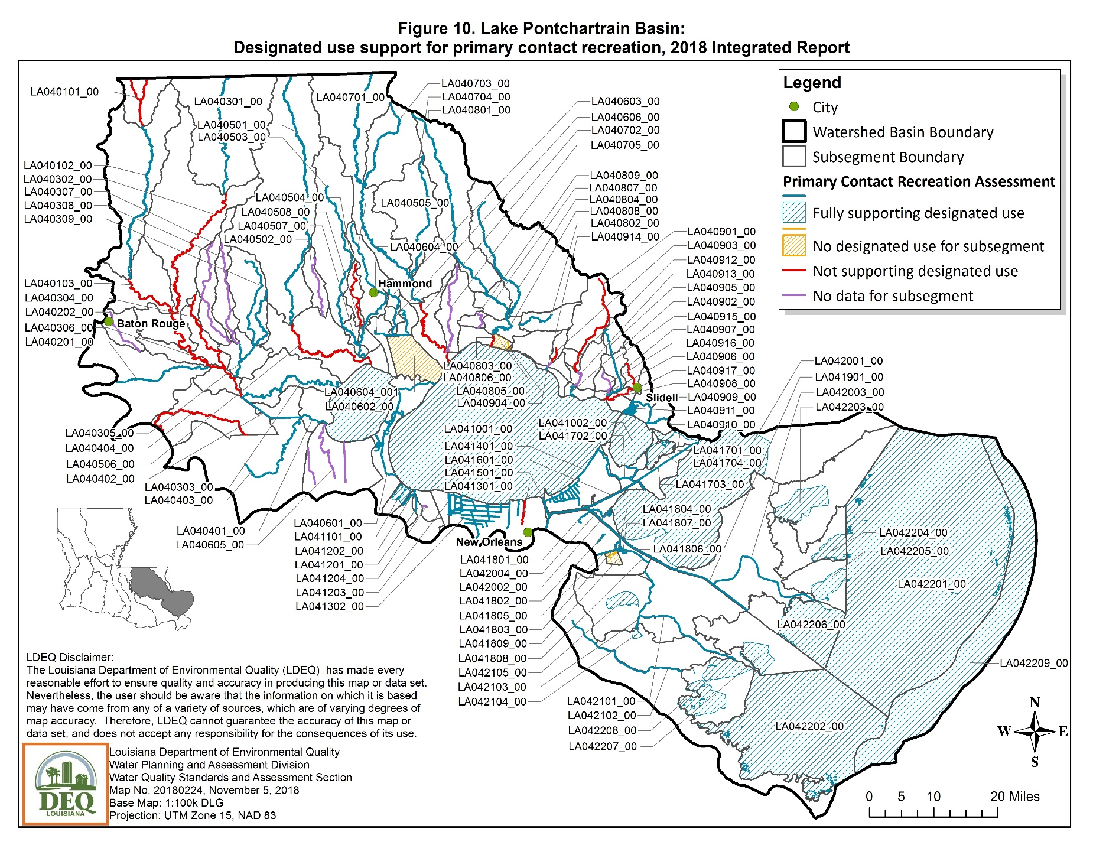
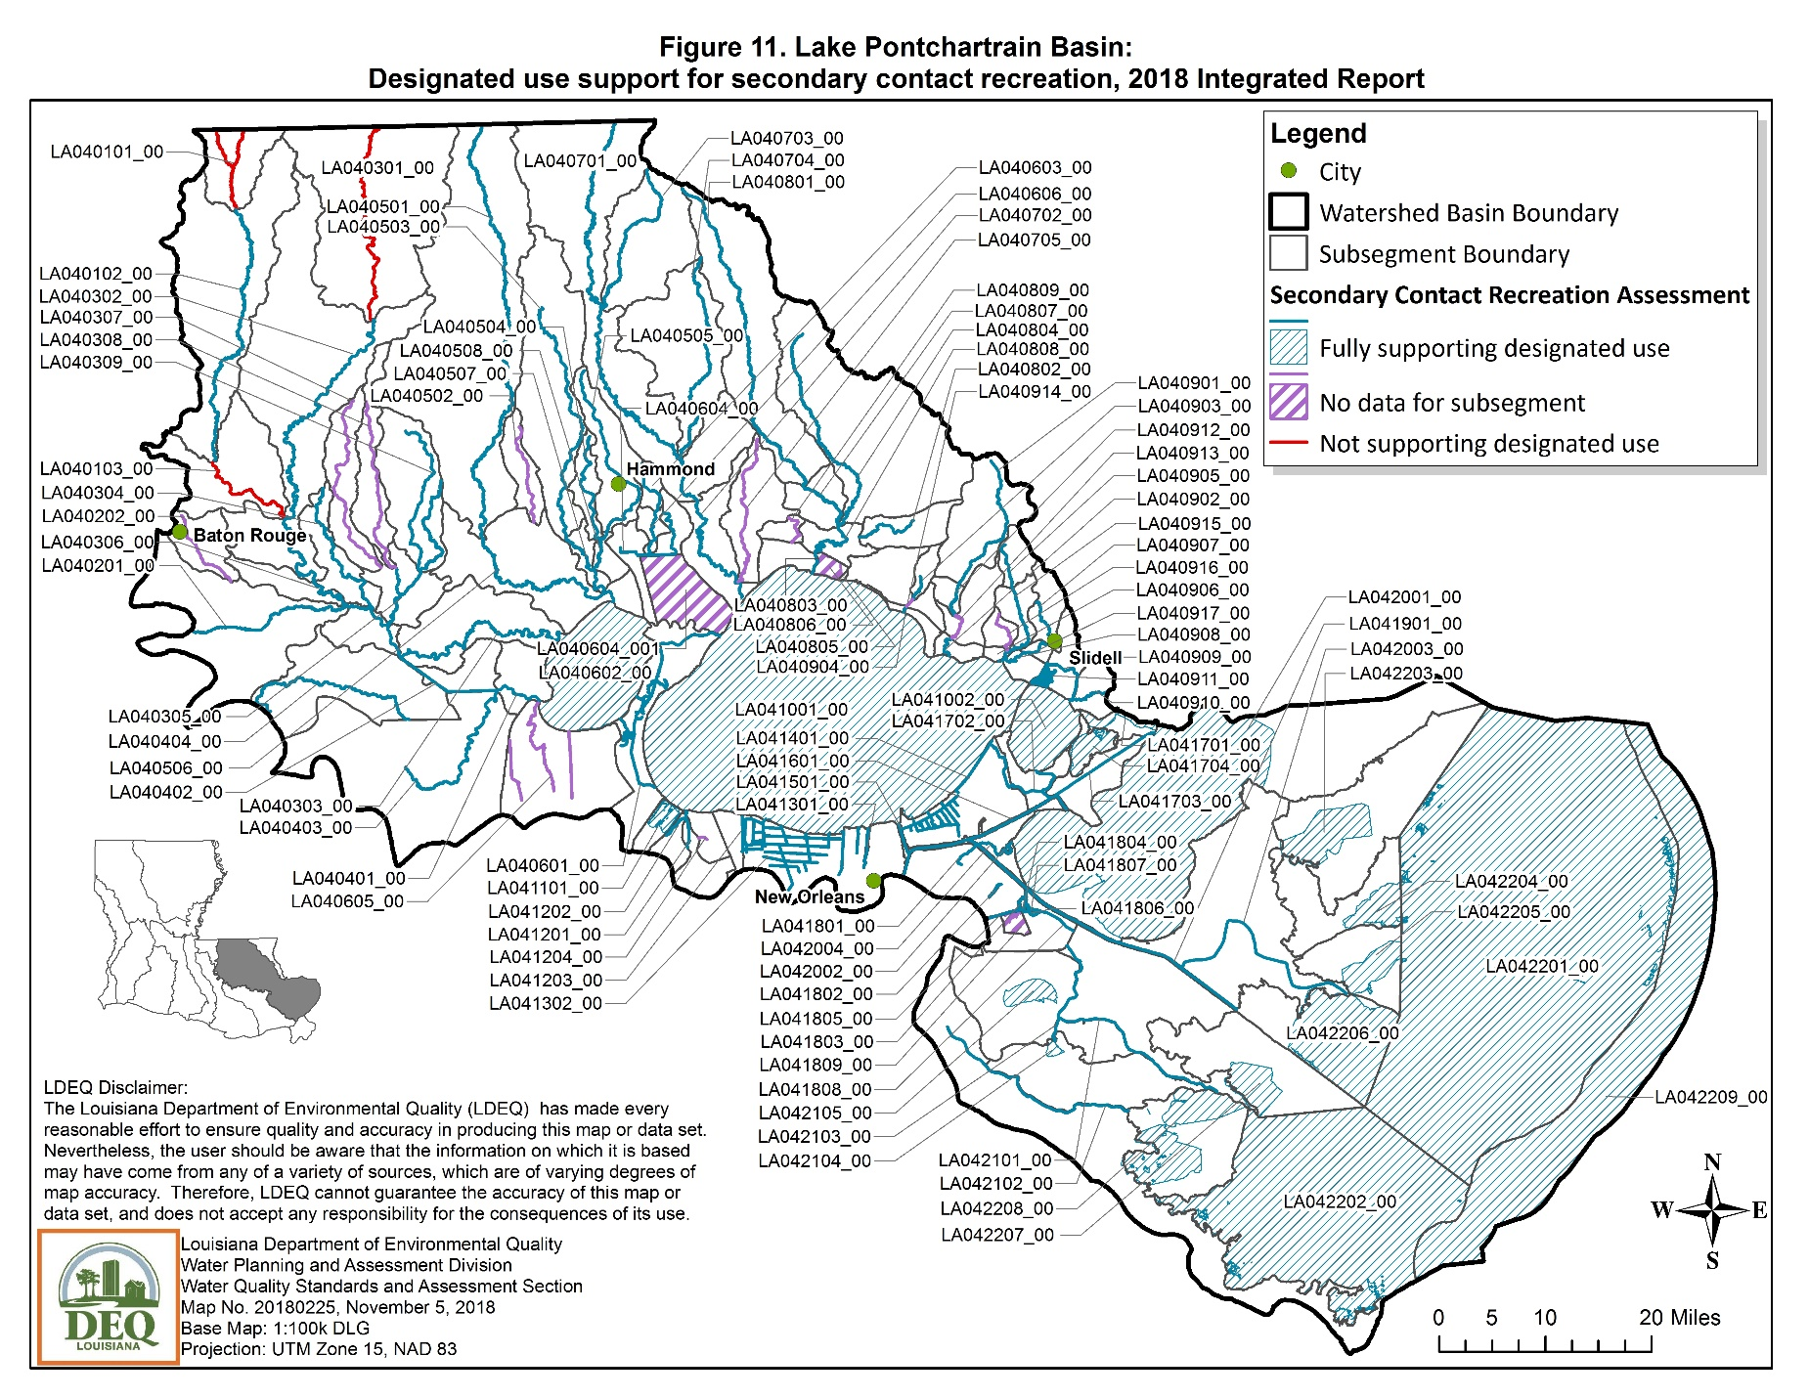
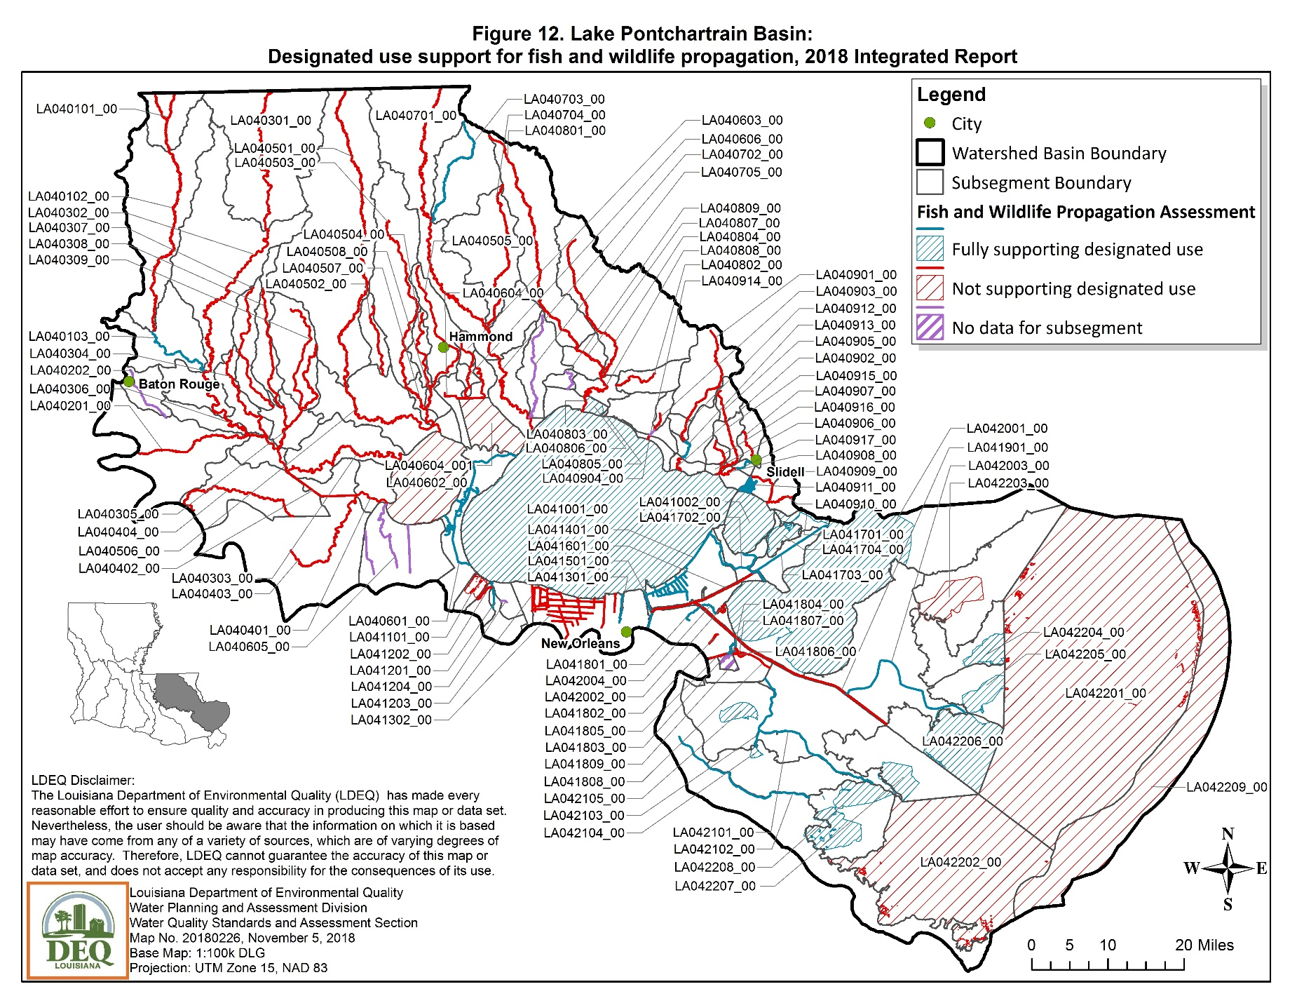

MERMENTAU RIVER BASIN (05)
The Mermentau River Basin is located in southwestern Louisiana and encompasses the prairie region of the state and a section of the coastal zone. The Mermentau River Basin is bounded on the north and east by the Vermilion-Teche Basin, on the west by the Calcasieu River Basin, and on the south by the Gulf of Mexico.
Maps showing use support for the three most significant designated uses of primary contact recreation (swimming), secondary contact recreation (boating), and fish and wildlife propagation (fishing) are on the following three pages.

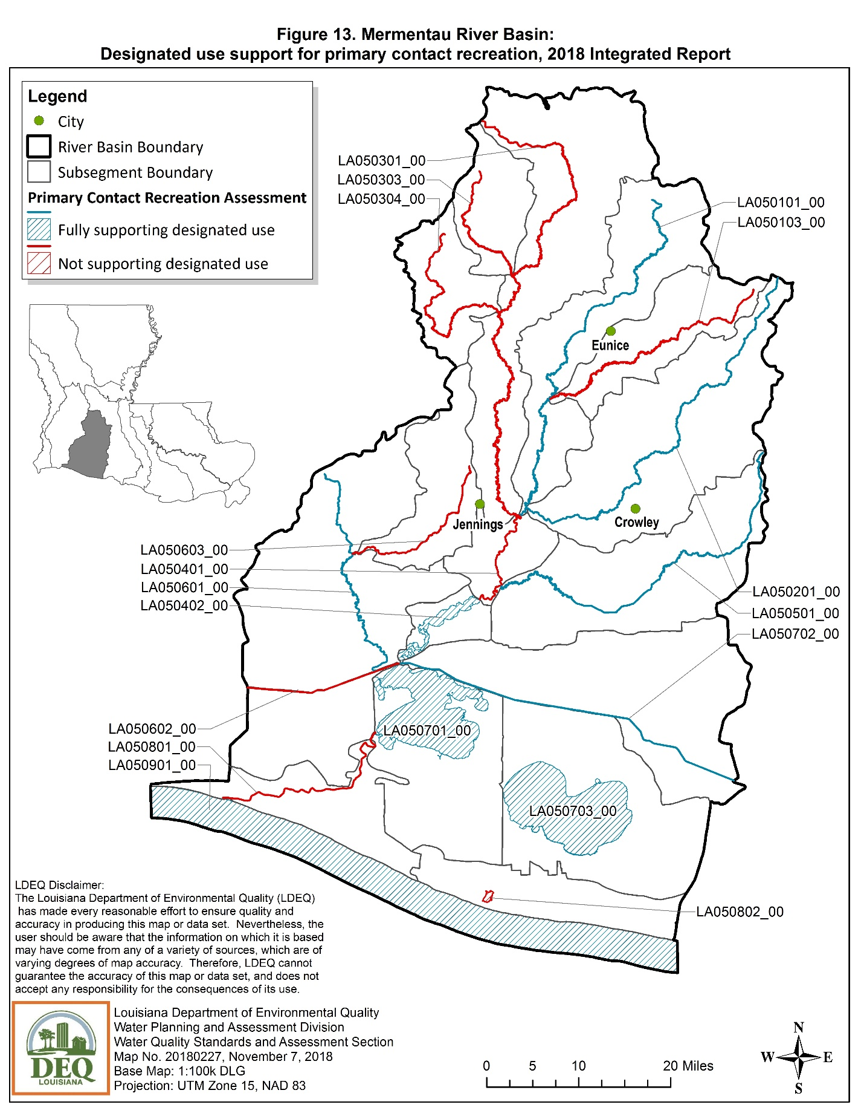
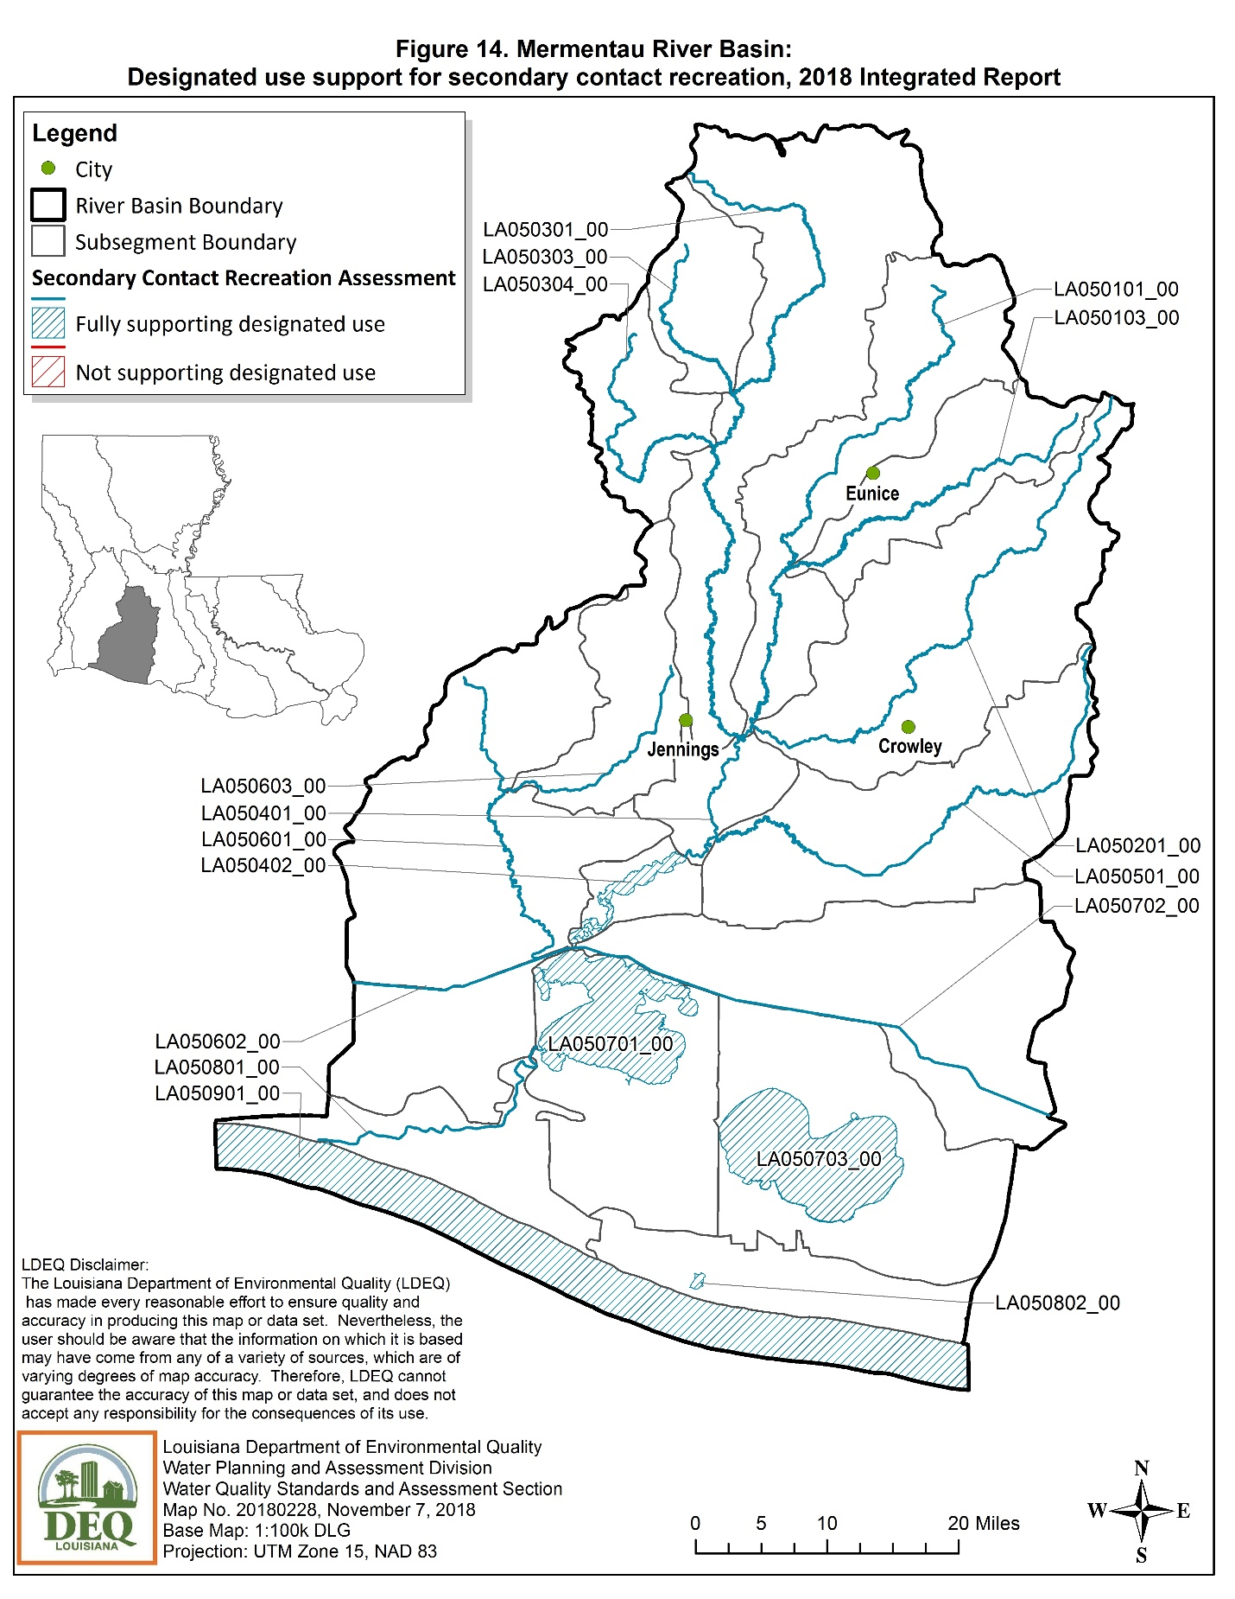

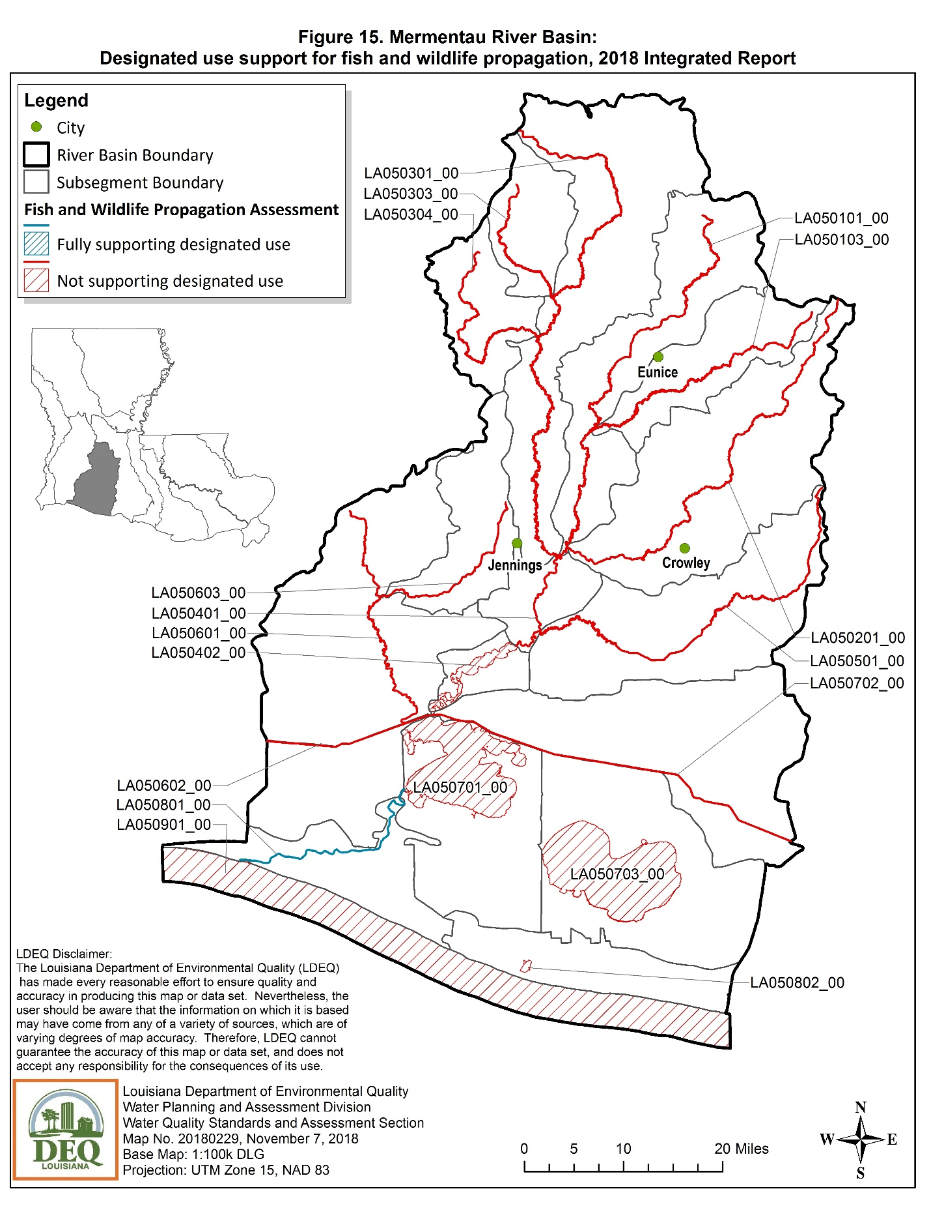
VERMILION-TECHE BASIN (06)
The Vermilion-Teche River Basin lies in south central Louisiana. The upper end of the basin lies in the central part of the state near Alexandria, and the basin extends southward to the Gulf of Mexico. The basin is bordered on the north and northeast by a low escarpment and the lower end of the Red River Basin. The Atchafalaya River Basin is to the east, and the Mermentau River Basin is to the west.
Maps showing use support for the three most significant designated uses of primary contact recreation (swimming), secondary contact recreation (boating), and fish and wildlife propagation (fishing) are on the following three pages.

