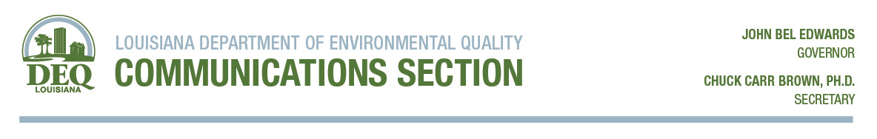
For Immediate Release: Contact: Greg Langley
Sept. 25, 2018 Telephone: 225-219-3964

Lake Charles man charged with the illegal disposal of gasoline

BATON ROUGE – Yesterday, investigators within the Criminal Investigation Section of the Louisiana Department of Environmental Quality arrested a Lake Charles man on two counts of knowingly disposing of gasoline into a stormwater retention pond. Under Louisiana law, knowingly discharging a substance that could endanger human life or health in contravention of Department regulations is a felony.

Dean Garrett Domingue, 54, and his accomplice, David Mouton, 51, illegally discharged 200 gallons of a gasoline and water mixture into a stormwater retention pond behind the Albertson’s Grocery Store located at 2750 Country Club Road in Lake Charles on the night of January 23, 2017. After this incident, representatives from Albertson’s spent more than $49,000 cleaning up the spilled material and remediating the damages caused by the spill.

Domingue and Mouton dumped more gasoline into the storm drain behind the Albertson’s Store on the night of March 19, 2017, in an effort to compromise the LDEQ investigation against them. They then called the LDEQ to report the second incident using a fictitious caller name and fictitious information regarding the responsible party.

After extensive investigation and interviews with both Domingue and Mouton, LDEQ CIS obtained felony arrest warrants for the two men on September 17, 2018. LDEQ CIS arrested Domingue on September 24, 2018.

Mouton remains at large while wanted on two counts of knowingly discharging a substance that could endanger human life or health.

“Our rules are in place to protect the environment, and anybody who willingly and knowingly violates them will be held accountable,” said LDEQ Secretary Dr. Chuck Carr Brown.

If convicted of knowingly discharging a substance that endangers or could endanger human life or health, Domingue and Mouton face possible imprisonment for not more than 10 years with or without hard labor, or a fine of not more than $100,000, or both, according to LDEQ.

The mission of the Louisiana Department of Environmental Quality is to protect the environment and public health. Any persons with knowledge of any spills, releases, odors, fish kills, open burning, waste tires and any other types of environmental incidents may contact the department at 225-219-3640 or Toll Free 1-888-763-5424.

An arrest does not constitute guilt in a criminal case. All evidence compiled during the investigation is presented to the area prosecutors who determine if formal charges are warranted.

-30-

