LOUISIANA
Application for Approval of Emissions
of Air Pollutants from Part 70 Sources

Paperwork Reduction Format

Instructions

Introduction and Scope
The purpose of the Paperwork Reduction Format of the Louisiana Application for Approval of Emissions of Air Pollutants from Part 70 Sources is to provide information to the Louisiana Department of Environmental Quality (DEQ) Air Permits Division in a manner that reduces the review time for the application. This is accomplished by removing certain sections of the permit application form that do not require review. The removal of these sections of the application form is dependant on the specific proposal made by the applicant and the type of permit for which an application is prepared.

At this time, this form may only be used for permit applications for minor modifications as defined in LAC 33:III.525. In the future, use of this form may be expanded to other permit types but is currently restricted as noted above. Use of the Paperwork Reduction Format is completely optional. The applicant may choose to utilize the full version of this form at any time.

How To Use The Paperwork Reduction Format
Open the form. Once it is open, a warning will appear informing the user that the file contains macros. Ensure that macros are enabled. If macros are not enabled, the form will not automatically remove the sections of the application that are not needed for review. The warning message should look similar to this:

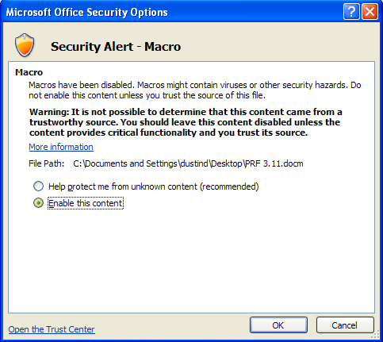

Once macros are enabled, the following screen will appear:

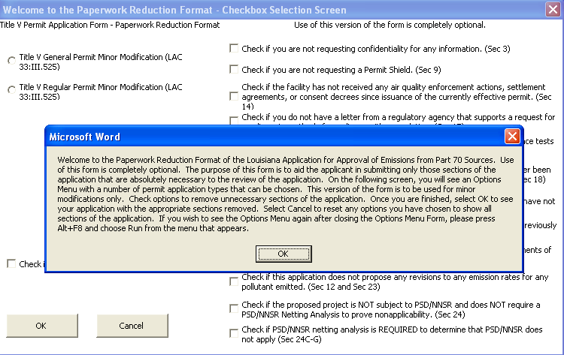

After reading the message, click OK. The message will disappear.

The screen that remains will have a number of buttons and checkboxes for the applicant to use. The checkboxes on the right side of the screen will remain grayed out until the applicant chooses the permit type for which an application will be submitted. At present, the applicant may only choose to apply for a Title V General Permit Minor Modification or a Title V Regular Permit Minor Modification. Once the applicant has chosen a permit type, the checkboxes on the right side of the screen will become active. Check or uncheck each box according to the text found to the right of the checkbox. The parenthetical section reference for each checkbox denotes the sections of the permit application that are affected by selecting the checkbox.
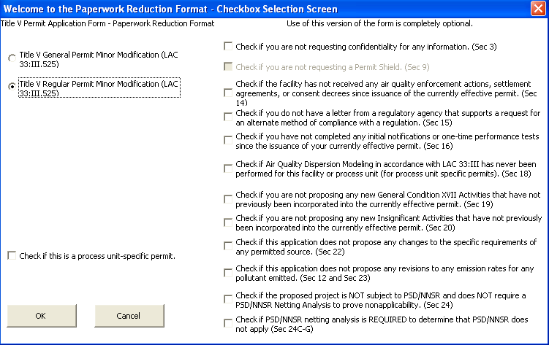

The boxes that should be selected are dependant on the specific circumstances of the proposed application. For example, if the proposed minor modification will not seek to revise any emission rates from currently permitted levels, the applicant can choose the checkbox with the reference to Sections 12 and 23 of the permit application. The applicant may choose as many or as few checkboxes as necessary to accurately define the proposed minor modification request.

If a checkbox becomes grayed out, it means that a previous choice made by the applicant precludes the applicant from making the choice. For example, indicating that the proposed project is not subject to PSD/NNSR and does not require a netting analysis will cause the checkbox that allows the applicant to perform a PSD/NNSR netting analysis to become grayed out. If the project will not require a netting analysis to prove PSD/NNSR non-applicability, there is no need to select the checkbox that allows for this. If the applicant should later decide that a PSD/NNSR netting analysis is required after all, simply uncheck the incorrect box and the correct box will become active again.

After making the desired selections, click OK. The Checkbox Selection Screen will close and the applicant will be able to view the permit application form. Sections of the application form will be removed from the application depending on the choices made in the previous screen. The applicant may then complete the form as necessary to convey the required information.

Section 26 has been added to this form. The purpose of this section is to communicate to LDEQ the fact that certain sections of the permit application have intentionally been omitted. Based on the choices made by the applicant in the checkbox selection screen, this section will be properly completed automatically. In addition, Section 4 of the permit application will be completed automatically to show the permit type being requested.

How To Alter the Form After Exiting the Checkbox Selection Screen
If the applicant wishes to change the choices made in the Checkbox Selection Screen after closing the screen, press Alt + F8 and click the Run button. This will cause the Checkbox Selection Screen to reappear.

How to Reset the Form
The form will reset itself to show all sections of the full version of the application form each time the user opens the Checkbox Selection Screen or chooses Cancel from the Checkbox Selection Screen.

